Captain Bob
- Ship's Master
- Member

- 108 posts
- Location:Sacred Tomato, CA
- Interests:Science, technology, history, military history, etc.
Posted February 27, 2006 · Report post
I am preparing for my next pirate-related project. Using only hand tools, I'd like to build a seaman's chest and, for lack of a better term, a "treasure chest" (wooden strong box).
I have a few questions, but would like to solicit as much information as possible. My kit thus far is more theatrical than historical, but I would like to at least pass the ten-foot-rule with these two boxes.
- About how big was a seaman's chest?
- About how big should I make a "treasure chest".
- I'm simply not equipped to work in wought iron. Any suggestions on how to simulate iron bands on the treasure chest?
- Can anyone provide links to photos of the genuine article?
Thanks in advance.
Yr Obt Svt, Captain Bob

Fox
- Old Twillian
- Moderator

- 2,564 posts
- Gender:Male
- Location:Beautiful lush Devon, England
- Interests:Nautical history of the 16-18th centuries and living history based thereon.
Shooting pirates.
Posted February 27, 2006 · Report post
1740. Probably a bit on the big side to be a sea chest, but they weren't uniform sizes.
1700. These are probably a more realistic size for sea chests.

Sea chest recovered from the wreck of the Kronan, 1676
Some chests from the Vasa, 1628.

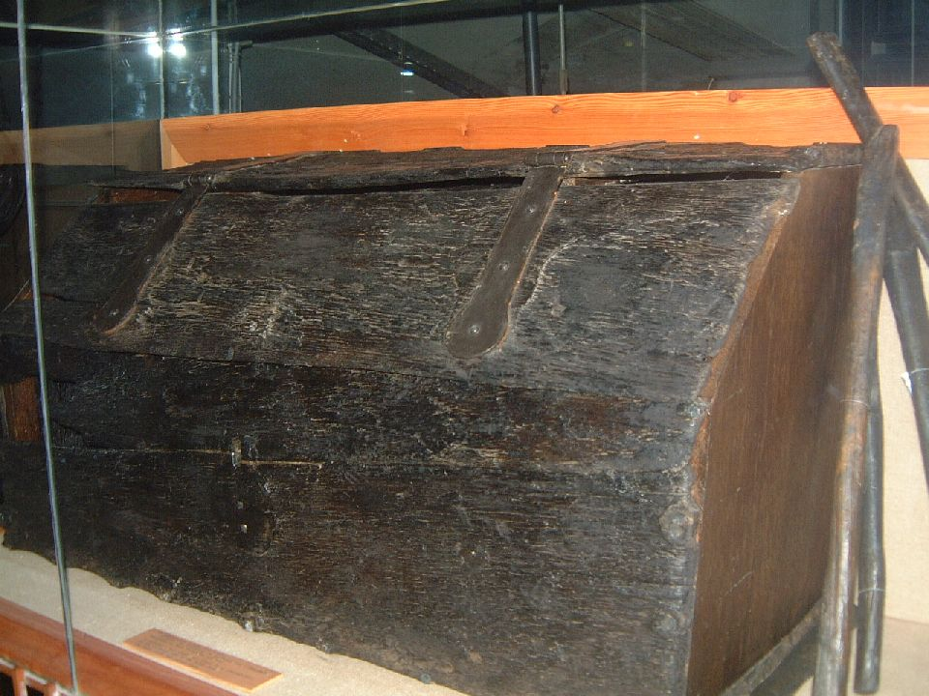
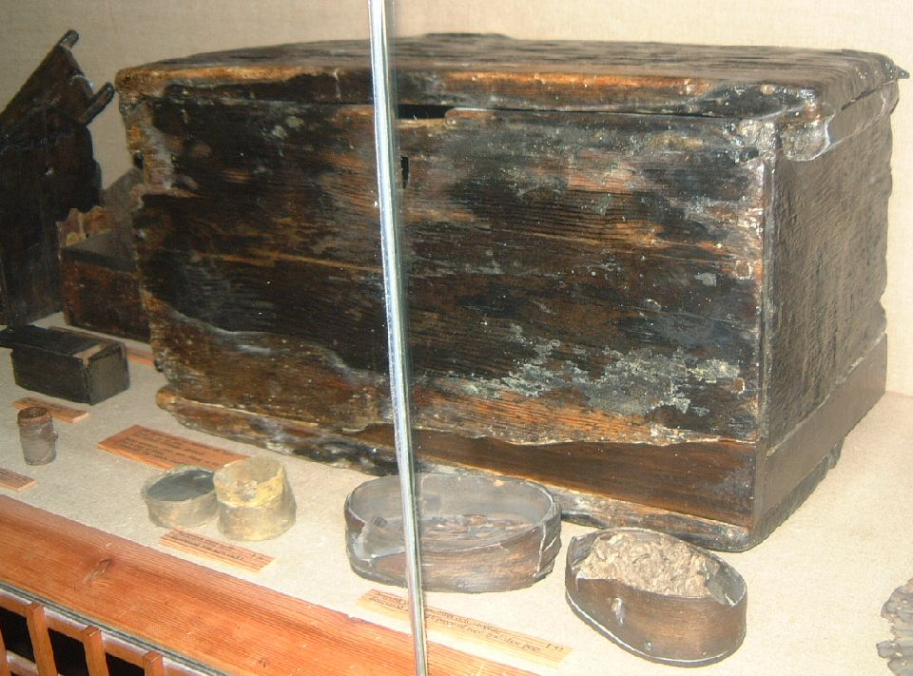
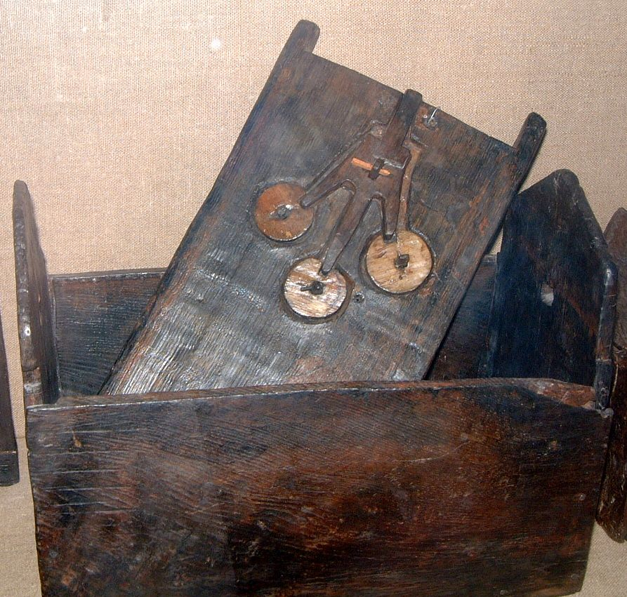
View of the lock on an interesting shaped chest.

Chest supposedly belonging to Thomas Tew, but its provenance is doubtful.

JoshuaRed
- Dread Pyrate
- Member

- 1,342 posts
Posted February 27, 2006 · Report post
LOL I always wondered HOW the heck they "proved" that, Foxe. I sure hope it's Tew's though, for Pat Croce's sake...he's the guy that paid a small fortune for it.

Capt. Bo of the WTF co.
- Scourge o' the 7 Seas
- Member

- 2,339 posts
- Gender:Male
- Location:Spanish Louisiana - on the river Osage
- Interests:Many and varied.
Posted February 27, 2006 · Report post
Cap'n Bob...
Try your nearest metal fabrication shop. Most of them scrap tons of shear "drops" and many will be willing to let you sort trough the scrap bin. I suggest no thicker than 12-14 guage for your project, as this can easily be bent over a bench vise or wok bench edge. Taking a ball peen hammer of medium to large size and hammering "pings" on the surface will imitate the forged look quite nicely. Most hardware stores carry strap steel, but it is highly expensive. Drills and hand filing, as well as hacksaw and elbow grease... and voila!
Once you get the banding cut and shaped, put the pieces in the oven at 450 for about 4 hours prior to the final installation. This will both age and temper the steel.
Good luck!.... Capt. Bo

dasNdanger
- Plunderer
- Member

- 320 posts
- Location:NJ
- Interests:Tall ships, Native American history and culture, rugby...and just about anything that predates 1900...
Posted February 27, 2006 · Report post
Captain Bob said:
[*]I'm simply not equipped to work in wought iron. Any suggestions on how to simulate iron bands on the treasure chest?
Okie dokie - I'm no expert, but I do have artistic tendencies...
If you note, not all the chests have iron bands. So, technically, you could get around it. However, what about leather straps? we have an old steamer trunk, and it has some leather strapping on it. Leather or rope handles...though finding large, iron handles may not be a problem (in most home improvement stores or hardware stores, the drawer pulls/handles are getting really large, some are made in iron). Also, you could contact a blacksmith or something - sure the guys here can point you in the right direction. I have an old chest of drawers that I need drawer pulls for, and canNOT find in the right size (center hole width) - so I'm thinking of contacting a smithy to see if they can make me what I need.
However, if you really want an 'iron band' look...perhaps you could use stainless steel Band-it, painted black. (we get it through marine supply stores) http://www.band-it-idex.com/products_bandit.asp
I haven't worked with it, but me pa says it's bendable. Not sure about width, etc - you'd have to take a look around. However, it might provide too smooth a look, not sure...but it's a start...
das

Gentleman of Fortune
- Dread Pyrate
- Member

- 1,456 posts
- Gender:Male
- Location:Germany... Franconia (northern Bavaria)
- Interests:I *used* to be an environmental scientist, until I married a DoDDs teacher in 1997. Since then, I have been living in, and traveling around, Europe (First the UK, now Germany).
My hobbies are all the "usual suspects" for those interested in re-enacting and Golden Age of Piracy stuff.... but I have drifted away from the pirate scene as my location and young family don't allow for any more than "virtual" pirate participation. Besides Piracy, I am into Reverend Guitars and Vintage Corvettes.
Posted February 27, 2006 · Report post
As you can tell by the pictures that Foxe's posted, bands aren't needed for a sea chest.
I think people confuse two different things though.
A sea chest is what sailor would put his belongings in (i.e. clothes and personal items) which is what Foxe's has posted.
The other chest we are thinking about is the "pirate chest" that we think of when we talk about burried treasure. I think that kind of chest might be a more secure variety with banding and what not. I seem to recall them being called a "coffer".
Seems like the simple sailors sea chest would be the easiest to build.
GoF

dasNdanger
- Plunderer
- Member

- 320 posts
- Location:NJ
- Interests:Tall ships, Native American history and culture, rugby...and just about anything that predates 1900...
Posted February 27, 2006 · Report post
Also, big ol' iron hinged hasps should be easy to find (hardware, blacksmiths, etc), and can give the illusion of extensive iron work though only the hasp is iron. Iron corner thingys (protectors) can also add to the effect. Lot's of possibilities here... http://www.antiquehardware.com/subcategory/63/ and here http://www.acornmfg.com/browse.php?cId=6&scId=19
OOO!! I think I wanna make me own chest now.... :)
das

Patrick Hand
- The sailor's sailor
- Moderator

- 6,100 posts
- Gender:Male
- Location:TH' Mountains of Central California
- Interests:I like wierdness... Klingon, Pyrate..... and even..... gasp.... Renn Faires...... (Baseball and tractor pulls I'd have to think about.... could be wierd or Not,,,,)
Posted February 27, 2006 · Report post
Cool.... the Sea chest recovered from the wreck of the Kronan, 1676, has dovetailed edges...... the one right above the "interesting lock" is pegged.....
Too bad that I can't see if there was a "block" for the handles to go through...
Making a sea chest is a possible future project......but the detail in the photos ansewers some of my questions..........

HarborMaster
- Dread Pyrate
- Member

- 1,446 posts
- Gender:Male
- Location:Centralia Wa and Cebu Philippines
- Interests:Scuba Diving ., Shooting ., Drinking ., Cannons ., Motorcycling . I hope I didn't , leave out anything important.
Posted February 27, 2006 · Report post
A Treasure Chest or Coffer would be considerably smaller., mine ( homemade non-period correct ) is 10" deep by 15" in length., by 12" tall . You have to remember if a treasure chest is an item you want to make it would be alot smaller than a sea chest for stowing items. Gold is heavy and a big wooden chest would not be able to hold itself together nor would you be able to pick it up. Treasure chests (Coffers) are small., something you could put on a table and be able to count its contents. Steel would really add to its strong-box appearance.
Also I must agree the steel is pretty easy to work with .,I am no iron worker and mine looks pretty good..,and has alot of steel on it.
With simple tools a bit of for thought and a little time. A 50 dollar die grinder will do alot., so will a file .., a cheap hand held jig-saw..,small tools.
When I make one I use card board templates on the chest once I get those perfect I have my patterns. Also by using card board you can lay it flat and mark all of your holes and then put them in your metal prior to bending the metal. This will give your nail holes a more perfect lay-out after the bends are finished and the pieces come together.

Swifty Morgan
- Ship's Master
- Member

- 144 posts
Posted February 27, 2006 · Report post
HM That is not period correct....
HMS Victorys Signal Cannon that is 1805 NOT PERIOD!
That is Wild Imports interpretation of an HMS Victory Signal Cannon would not be period. That is 1805
The Chest is a Fantasy Chest you built based on Robert Louis Stevenson 1889 NOT PERIOD!
Ohhhhh and the Mardi Gras Beeds NOT PERIOD! The Mardi gras beads how ever are 2006 Gasparellla Pirate Fest period correct.
Be Careful HM Ye Be warned.....
The Ketland trade pistol is also 1802 - 1805 NOT PERIOD!
Maybe though GAoP is not the only period for Sea Bandits
Of Course 1805 was a period tho not GAoP. Come to think of it they had pirates in 1805. We still have Pirates today with automatic weapons.
GOOD JOB!!!! Can I have one of those Gasparella Doubloons.

HarborMaster
- Dread Pyrate
- Member

- 1,446 posts
- Gender:Male
- Location:Centralia Wa and Cebu Philippines
- Interests:Scuba Diving ., Shooting ., Drinking ., Cannons ., Motorcycling . I hope I didn't , leave out anything important.
Posted February 27, 2006 · Report post
Sure you can have one., reach into that thar chest with yer hand....................................,and I'll be kickin the lid shut an stepping on the lid whislt I unload me pistol ya scurrvy good fer nuthin bilge rat !

Gentleman of Fortune
- Dread Pyrate
- Member

- 1,456 posts
- Gender:Male
- Location:Germany... Franconia (northern Bavaria)
- Interests:I *used* to be an environmental scientist, until I married a DoDDs teacher in 1997. Since then, I have been living in, and traveling around, Europe (First the UK, now Germany).
My hobbies are all the "usual suspects" for those interested in re-enacting and Golden Age of Piracy stuff.... but I have drifted away from the pirate scene as my location and young family don't allow for any more than "virtual" pirate participation. Besides Piracy, I am into Reverend Guitars and Vintage Corvettes.
Posted February 27, 2006 · Report post
Good points HM....
I hadn't even thought about how heavy a big ol' chest would be loaded with stuff (especially gold/silver).
That being said, the coffers can be pretty big, but a non-maritime one was probably not meant to be moved (whereas a sea coffer would have to be portable).
There is an Abbey ruin in Castle Acre (UK) that still has a huge coffer in one of the rooms. The coffer must have been assembled on site as its too big to get through the door!
GoF

HarborMaster
- Dread Pyrate
- Member

- 1,446 posts
- Gender:Male
- Location:Centralia Wa and Cebu Philippines
- Interests:Scuba Diving ., Shooting ., Drinking ., Cannons ., Motorcycling . I hope I didn't , leave out anything important.
Posted February 27, 2006 · Report post
I would love to go to the UK and see some of these things.,especially the TOWER !!! and its armory! And that Coffer., It would be hard to imagine what was once in it?
On the chest topic however I did mine in oak., but I would think alot of differant hardwoods would be fine and were probably used due to the weight of thier load? But for a sea chest I am not sure what a person would use to make a sea chest? I need to make 4 . One for each motel room., we will be using 1 at the foot of each bed as opposed to a chest of drawers. Guests can use that for their clothing.
I would think a hard wood .,would probably be out., due to the weight of the wood. A seaman had to lift the chest and its contents. Would a cypress or a type of cedar be more common?. Pine? This is something I am curious about too.

JoshuaRed
- Dread Pyrate
- Member

- 1,342 posts
Posted February 27, 2006 · Report post
I'm with ya HM...I would LOVE to tour the Tower. And the National Maritime Museum. And I'd love to spend a season in the National Archives.

kass
- Scourge o' the 7 Seas
- Member

- 1,526 posts
- Gender:Male
- Location:Easton, Pennsylvania
- Interests:Historical Clothing from the 14th through 18th centuries. Getting all the niggling details right. Dressing up and having fun with my similarly-obsessed friends. :)
Posted February 27, 2006 · Report post
Oh come on, guys, you're making me covet! I want to go to the Tower and the National Archives and Leeds...
But I only have six days, and I only get two of those in London. I'll be lucky if I see half the things on my short list for the V&A!

Fox
- Old Twillian
- Moderator

- 2,564 posts
- Gender:Male
- Location:Beautiful lush Devon, England
- Interests:Nautical history of the 16-18th centuries and living history based thereon.
Shooting pirates.
Posted February 27, 2006 · Report post
The National Maritime Museum is a big dissapointment IMHO. Some of the big stuff is great, and the art gallery is FANTASTIC, but the museumy bits are so dumbed down it's unreal. Period navigation is one of my particular interests, and I know that the NMM have one of the finest collections of instruments in the world, so I toddled along to that particular gallery, all full of excitement. There were about 5 or 6 things on display, with big pretty coloured boards to tell the idiots the most basic of information, and when I looked closely the instruments themselves were modern replicas! The rest of the museum was pretty similar. That was about 5 years ago so it might have changed, but it didn't inspire me for a return visit.
The wood used for chests would probably depend on where you were. Pine was a luxury wood until quite recently in England for example, but was much more readily available in the Americas. Descriptions of chests from period documents:
a Chest covered with a hide
1 Burmuda Ceder Chest
a pyne chest
Also loads of "Spanish" chests, old, large, small, new chests etc.
You want large coffers? The first Chatham Chest:

Captain Bob
- Ship's Master
- Member

- 108 posts
- Location:Sacred Tomato, CA
- Interests:Science, technology, history, military history, etc.
Posted March 17, 2006 · Report post
- Measure twice
- Cut once.
- Examine part you just cut.
- Scratch head and mutter: "Wutthehell happened?"
As a carpenter, let's just say I need practice. Fortunately, my next door neighbor is an experienced woodworker and I was able to enlist his help. I told him what the parts should look like and what their dimensions should be. He did the ever-so-critical measuring and cutting. We assembled the wooden bits and then he handed the project over to me for completion.
I stained the box and finished it with satin-finish spar urethane. I then attached the hinges, draw latch, and handles. For "iron bands", I used ¾" wood trim, painted with Rustoleum Hammered Metal finish, and attached with glue and decorative brass furniture nails.
Tomorrow, My mom will take it to my sister so she can photograph it and email me the pics. I'll post the pics ASAP.
--Cap'n Bob
P.S.: In return for my neighbor's assistance in making this treasure box, I'm going to help him design and build a blanket chest for his wife.

Barber-surgeon
- Deck Hand
- Member

- 64 posts
Posted March 17, 2006 · Report post
Indeed, Cap'n Bob! We be most anxious ta see yer photos of said chest! Question, how much does it weigh empty?
Cheers! :angry:

Captain Bob
- Ship's Master
- Member

- 108 posts
- Location:Sacred Tomato, CA
- Interests:Science, technology, history, military history, etc.
Posted March 17, 2006 · Report post
Barber-surgeon said:
Indeed, Cap'n Bob! We be most anxious ta see yer photos of said chest! Question, how much does it weigh empty?
Cheers! :angry:
Whups! I forgot to give dimensions. (It's on its way to my sister's so I can't weigh it.) disregarding the hardware and "iron straps", it's about 8" wide by 7" deep by 7½" tall, so it's nearly a cube.
Next time I make one I'd like to use antique hardware. This time around I just bought modern decorative brass hinges, a draw latch/hasp, and two brass drawer pulls for the side handles. The body of the box is made from pine 1×6's (bottom and sides) and pine 1×2's (everything else). I'm guessing it weighs about 5-10 pounds, but I'm not calibrated so I could be off by a considerable amount.
--Cap'n Bob

Barber-surgeon
- Deck Hand
- Member

- 64 posts
Posted March 17, 2006 · Report post
"it's about 8" wide by 7" deep by 7½" tall, so it's nearly a cube."
Erm...inches? :angry:

Capt. Bo of the WTF co.
- Scourge o' the 7 Seas
- Member

- 2,339 posts
- Gender:Male
- Location:Spanish Louisiana - on the river Osage
- Interests:Many and varied.
Posted March 17, 2006 · Report post
Barber -Surgeon... The quotation marks when used behind a number denotes inches here in the colonies mate.( 8"= eight inches ) Just something else to confuse our European friends! :angry:
Capt. Bo

Captain Bob
- Ship's Master
- Member

- 108 posts
- Location:Sacred Tomato, CA
- Interests:Science, technology, history, military history, etc.
Posted March 18, 2006 · Report post
Here's some pics of me tresure chest (small as it is).
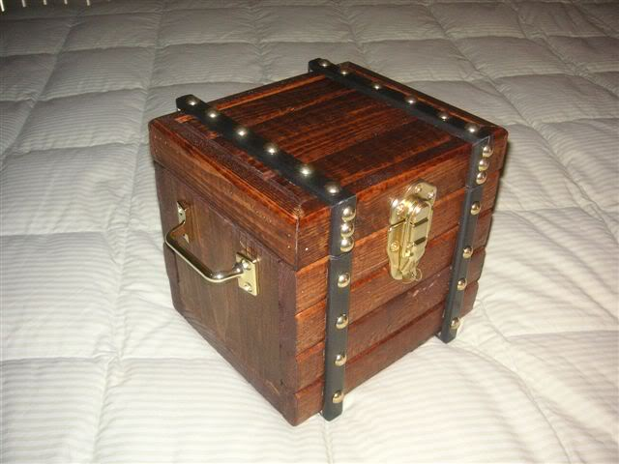
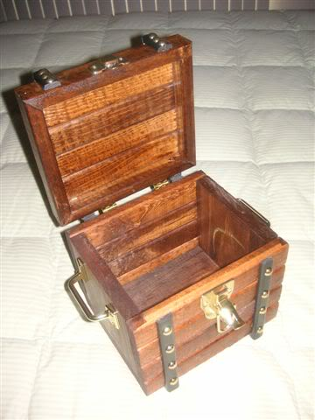
Well? Wadaya think?
--Cap'n Bob

Rumba Rue
- Immortal Pyrate
- Member

- 7,270 posts
- Gender:Female
Posted March 18, 2006 · Report post
I would have liked to have seen a more period laching front and less modern handles, and smaller studs. But all in all it's a very nice small chest.

JoshuaRed
- Dread Pyrate
- Member

- 1,342 posts
Posted March 18, 2006 · Report post
Wouldn't want to use that as my airplane carry-on piece!

Barber-surgeon
- Deck Hand
- Member

- 64 posts
Posted March 18, 2006 · Report post
Ah! So ye WERE meanin' inches...an' here I was thinkin' ye had built a full-scale reproduction. I greatly enjoyed the pic's! An' a fyne first job, too. A piece ye can use and have gleaned some good hands-on building knowledge from.
Definitly, I would agree with the suggestion for a wrought iron latch and handles with yer next construction.
Ye did a beautious piece of stainin' an' finishin' there, Cap'n Bob!
Cheers!

HarborMaster
- Dread Pyrate
- Member

- 1,446 posts
- Gender:Male
- Location:Centralia Wa and Cebu Philippines
- Interests:Scuba Diving ., Shooting ., Drinking ., Cannons ., Motorcycling . I hope I didn't , leave out anything important.
Posted March 18, 2006 · Report post
Thats a right fine go-round with the saw Captain Bob. Should hold a fortune in Gold and Gems. Yer mitered corners look good and the dark stain suits it well.

Captain Bob
- Ship's Master
- Member

- 108 posts
- Location:Sacred Tomato, CA
- Interests:Science, technology, history, military history, etc.
Posted March 19, 2006 · Report post
Credit where it is due. My neighbor, being more experienced than I at cabinetry, is responsible for the construction of the box and lid and for cutting the "iron bands" (he works as an installer for Home Depot) I designed the box, finished the wood bits and attached the hardware. If it looks good it's because I didn't cut any of the wood. If I had, it would have looked something like Charlie Brown's kite after the kite-eating tree got through with it.
The next one (when I get around to it) will be larger and have more iron (and less brass).
--Captain Bob

Kathyrn Ramsey
- Deck Hand
- Member

- 99 posts
- Location:http://www.freewebs.com/guildofstbarbara/
Posted March 19, 2006 · Report post
It came out very well Capt... you should be proud of the work you and your neighbor did... and you can always age the brass a bit so that it looks older and not so shiny.

Daniel
- Pyrate Captain
- Member

- 652 posts
- Gender:Male
- Location:McLean, VA
- Interests:History, pirates, fiction, writing, writing historical fiction about pirates, jokes, games, law.
Posted March 19, 2006 · Report post
I notice that while most of the chests here are flat-topped (including Captain Bob's, and congrats), there is at least one period chest with a hump-backed lid like in the Howard Pyle paintings. What is the purpose behind a hump-backed lid? Flat tops have a clear advantage in that you can stack flat-topped chests on top of each other, or use them as card tables or map tables. They would also appear easier to make. Yet someone went to considerable trouble to fashion hump-backed lids. Why?

Rumba Rue
- Immortal Pyrate
- Member

- 7,270 posts
- Gender:Female
Posted March 19, 2006 · Report post
Well actually I'm not sure, but mine has compartments built into the hump that open up for more storage.

HarborMaster
- Dread Pyrate
- Member

- 1,446 posts
- Gender:Male
- Location:Centralia Wa and Cebu Philippines
- Interests:Scuba Diving ., Shooting ., Drinking ., Cannons ., Motorcycling . I hope I didn't , leave out anything important.
Posted March 19, 2006 · Report post
Quote
I notice that while most of the chests here are flat-topped (including Captain Bob's, and congrats), there is at least one period chest with a hump-backed lid like in the Howard Pyle paintings. What is the purpose behind a hump-backed lid? Flat tops have a clear advantage in that you can stack flat-topped chests on top of each other, or use them as card tables or map tables. They would also appear easier to make. Yet someone went to considerable trouble to fashion hump-backed lids. Why?
For me? Personally I did it for the challenge .,also I wanted something not everyone has.,and lastly.,because I can.
With this in mind we have to remember a sea chest is for storage and would indeed be easier to stack (basically a portable clothing compartment) .
A "treasure chest" or a jewelry box however isnt just a wooden block., they are sometimes ornate and with a degree of style .,some boxes are more attractive than others used as a decorative piece perhaps in a room as the center piece for the top of a cabinet or dresser. You wouldnt want to display an old sea chest on a nice dresser would you?
Sometimes the detail and skill involved in a given project is a reflection of the artisans work and the price someone is willing to pay for it.
Its the same idea for why was a ship so decorated at the aft or the bow?
Why was a Cannon decorated with a Cypher and a crown?
Why would a person choose a curly maple when a lesser grade wood is somuch more easily affordable ?
I am going to have to give this one to personal preferance and point of purpose as well as place of use.

Silkie McDonough
- Proprietress of the Sealkies Hide
- Moderator

- 5,695 posts
- Gender:Female
- Location:I have been a Virginian for 2 months now. LOVING it.
- Interests:Music, vocalizing, Irish balads. I love to draw, I do pencile portraits/detail drawings for barter and sale. The link in in my signature. Ireland, its history and culture. Sewing garb, mostly for myself. The arm of a strong gentleman round my waist.
Unfortunately, I don't do nearly enough of any of a these.
Posted March 19, 2006 · Report post
I know that MANY years later, steamer trunks were made with curved surfaces BECAUSE they wouldn't stack well. That way the trunks with hump-back were stacked on the top and more easily accessible. Could the reason be a similar in the GAoP?

Capt. Sterling
- Sticky Fingers Sterling Needs a New Hat
- Member

- 10,302 posts
- Gender:Pyrate Hunter
- Location:here
- Interests:Killing pirates, haven't met one yet worth keeping alive....
Posted March 19, 2006 · Report post
Gee I always thought hump backed chests or rolled topped trunks were strictly a 19th century thing. I have two originals and they are both dated 1870s. All the trunk restoration sites seem to date rolled topped trunks with the straight sides around then. I also have a reproduction hair trunk circa 1770s, now that has a rolled top but the entire trunk is almost round, only the very bottom is flat. There is a chest in the V&A circa early 18th century and that has a flat top and most of the jewelry caskets are flat topped as well, but not all.
Would be interesting to find out more about the true period shape... as for all the talk about flat tops being better storage... with three somewhat round trunks in my keeping, I can't tell you what a mistake they were to purchase, I needed to get a trailer just to get camp gear to an event, you really can't put much on top of em....
Hector

HarborMaster
- Dread Pyrate
- Member

- 1,446 posts
- Gender:Male
- Location:Centralia Wa and Cebu Philippines
- Interests:Scuba Diving ., Shooting ., Drinking ., Cannons ., Motorcycling . I hope I didn't , leave out anything important.
Posted March 19, 2006 · Report post
Perhaps ? However I can see the point of literally using a big ol' chest for a table or too stack.
A "Treasure Chest" or a Jewelry box or a small sea going "Coffer" I cant really see being big enough for charting or gathering around to play poker. Probably it would have been hidden from the majority .
Again A Big TREASURE CHEST would need to be built of steel so it wouldnt blow itself out fromthe weight of its own contents..,
and call for a forklift to move.
I dont believe there is a such thing as a sea going BIG treasure chest. Gold is HEAVY Silver is HEAVY.
Ever try to pickup a 5 gallon bucket of tire weights or some other lead for molding your own shot for your flintlock (Used tire weights from Les Schwab make good lead shot ) ? I dont care how big you are.,you wont get far and a 5 gallon bucket isnt very big.
A portable coffer wouldnt be big. A portable coffer probably wouldnt be getting stacked with the average seamans clothing box.
Logic would dictate a heavy little chest.,and it would be kept low and hidden out of sight and made of tougher materials. Heavy is never stacked high.
I can see a small coffer being more decorative than the average seamans chest., you bet. Be it steel strapped., Finer woods.,a fancy top., nicer handles..,Poor people didnt have coffers., Admirals did., Merchant Captains., Rich travelors.,ect.,ect.,
If your going to hunt for treasure....,the first thing to do., is look for the ships manifest., find out who was on board and from that you can make a more educated guess if the hunt is worth it?

Ol Man From the Sea
- Ship's Master
- Member

- 121 posts
- Location:1/2 degree on the 270 radial from da big city on the third coast
- Interests:Pirates in Paradise, Women Pirates and pirate's Women, GAoP, Small airplanes that I can fly in or tiny ones I fly indoors, Sailin', Drivin' ah heck just Goin'...
Posted February 25, 2007 · Report post
All of the chest pictured here appear to have flat bottoms. Did gaop sea chest not have the runners found on landsman's chest? I recall one source saying that that often when a seaman retired he would have feet added to his chest for land use, but the source did not seem to be a reliable one. Any one have any thing to add?
Patrick Dovetails??? where??? it looks leather covered to me.
Also anyone know of any gaop period sea chest on display in the US?

CaptainSatan
- Notorious Pyrate
- Member

- 791 posts
Posted February 25, 2007 · Report post
Daniel said:
What is the purpose behind a hump-backed lid?
Most sea chests were the same chests used on land. The purpose of a round top on a traveling chest is to make it more water resistant. Water collects on a flat surface, but gravity will make it roll off of a rounded surface.The same reason most roofs are pointed and not flat...
-CS

Captain Jim
- Captain Jim for Captain!
- Member

- 2,254 posts
- Gender:Male
- Location:Off the coast of Tampa Bay (Unfortunately, inland from the coast)
- Interests:I'm 57, formerly a wildlife ecologist and biologist, now a stay-at-home dad. I grew up on the west coast of Florida, where Anna Maria Sound and Tampa Bay were my playground. My interests include, but are not limited to cannon, black powder arms, history, fishing the flats, sailing, fine wood working, flint gun building, hunting, good gun dogs. Above all, my wife and children.
Posted February 25, 2007 · Report post

The chest of Alexander Selkirk, a period sea chest, around 1712.
Arched top, large lid overhangs, dovetailed, overly massive lock system. Inscribed "AS" and "No. 34" on top.

Capt. Sterling
- Sticky Fingers Sterling Needs a New Hat
- Member

- 10,302 posts
- Gender:Pyrate Hunter
- Location:here
- Interests:Killing pirates, haven't met one yet worth keeping alive....
Posted February 25, 2007 · Report post

chests top from Vallejo Maritime Gallery,
Marine Arts and Artifacts Specialists
Quote
17th Century Iron Chest
Armada Strong Box
Sold
30½ Inches long x 17 Inches Wide x 17¾ Inches High Circa 1695
--------------------------------------------------------------------------------
An excellent example of an actual “treasure chest” from the 17th century, this heavy iron strong box possesses artistic touches which enrich its presence. Made of the heaviest iron construction by European craftsmen, these chests were sold to the sailing nations, including Spain, Portugal, the Netherlands and of course, England. Used to transport and secure gold, silver, documents and other valuables, once loaded and locked, it would be incredibly difficult to move.
Impressively artistic inside and out, this box has a presence which is eye- catching. Its exterior has painted floral motifs with a burnished patina, showing very much a Baroque Spanish influence. Heavy twisted iron beckets at each end had to have been hand-forged by a master smithy. The large original key fits the lock in the center of the lid, hidden under the swivelled panel, and triggers the 12 bolts which are the chest’s primary security. The interior locking mechanism is covered by a scroll-cut panel that features hand-inscribed floral work held by four men, with hats, baggy pantaloons and heeled boots. There is an additional locking internal compartment with key and a false escutcheon on the face of the chest, between the pair of vertical iron hasps which would hold two additional padlocks. Once a portable safe, this box is now itself a treasure.
and bottom V&A

CaptainSatan
- Notorious Pyrate
- Member

- 791 posts
Posted February 25, 2007 · Report post
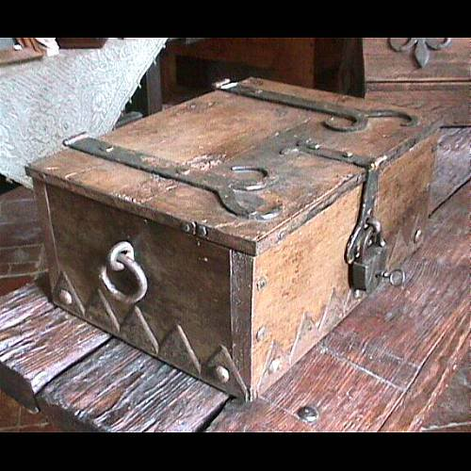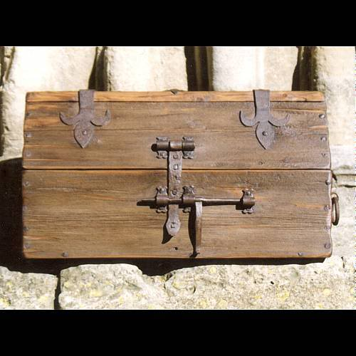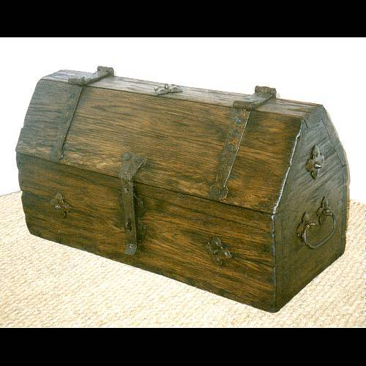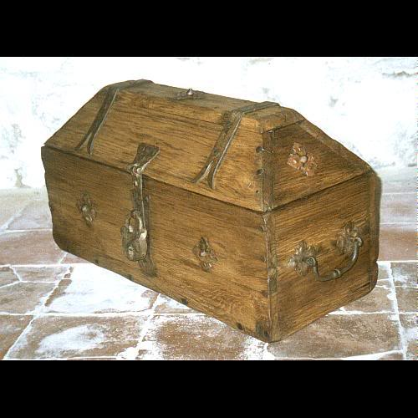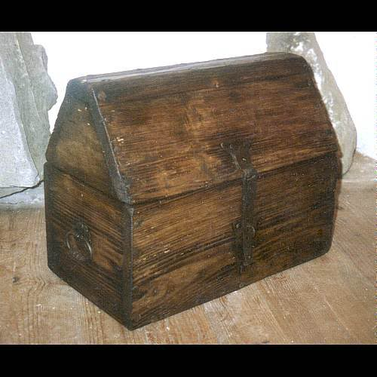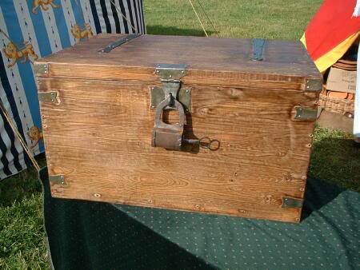

CaptainSatan
- Notorious Pyrate
- Member

- 791 posts
Posted February 25, 2007 · Report post
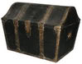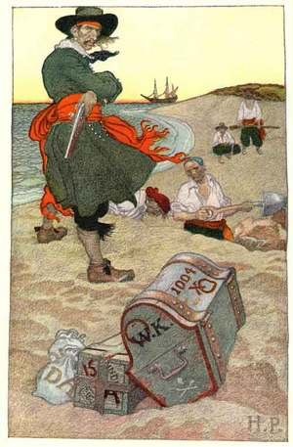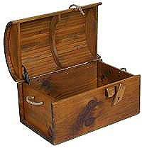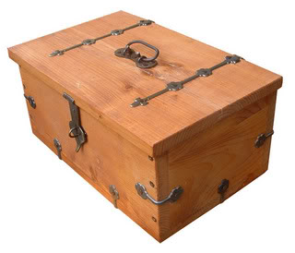

CaptainSatan
- Notorious Pyrate
- Member

- 791 posts
Posted February 25, 2007 · Report post
HarborMaster said:
I don't believe there is a such thing as a sea going BIG treasure chest. Gold is HEAVY Silver is HEAVY.
Perspective: A standard gold brick (7 x 3 5/8 x 1 3/4 inches) weigh about 27.5 pounds each.
-CS

Captain Jim
- Captain Jim for Captain!
- Member

- 2,254 posts
- Gender:Male
- Location:Off the coast of Tampa Bay (Unfortunately, inland from the coast)
- Interests:I'm 57, formerly a wildlife ecologist and biologist, now a stay-at-home dad. I grew up on the west coast of Florida, where Anna Maria Sound and Tampa Bay were my playground. My interests include, but are not limited to cannon, black powder arms, history, fishing the flats, sailing, fine wood working, flint gun building, hunting, good gun dogs. Above all, my wife and children.
Posted February 25, 2007 · Report post
Nice pictures of chests and all, but what are they and from when?
Provenance, man, give us the dates and origins of 'em.

capnwilliam
- Lost at Sea
- Member

- 1,287 posts
- Gender:Male
Posted February 25, 2007 · Report post
All the talk about "treasure chests" begs the assumption that pirates ever buried their treasure. There is little evidence in the historical record that they did. Also, what kind of sense would it make to do so?
"A short life and a merry one shall be my motto." These mates stole, divvied the loot, hit port, blew it - and did it all over again.
If you bury treasure: what's the point? You can't blow it. You can't invest it wisely. It's of no use to you until you come back and dig it up; by which point your "shipmates" may have beat you to the punch.
I don't mean to throw cold water on a fun wood-working project, though...
Capt. William

kass
- Scourge o' the 7 Seas
- Member

- 1,526 posts
- Gender:Male
- Location:Easton, Pennsylvania
- Interests:Historical Clothing from the 14th through 18th centuries. Getting all the niggling details right. Dressing up and having fun with my similarly-obsessed friends. :)
Posted February 25, 2007 · Report post
Thank you, Captains Jim and William, for turning this back to the historical. Provenance please. A pretty picture does us no good, people, if its origin is unknown. Remember: scholarly discussion of the GAoP...

CaptainSatan
- Notorious Pyrate
- Member

- 791 posts
Posted February 25, 2007 · Report post
The chests pictured above are basic designs used repeatedly from the Dark Ages well into the 18th century (except for the barrel top). Almost every variation of chest was used during the GAoP. Including but not limted to flat top,square, rectangle,barrel top, coffin lid, etc. Just about any chest would be used during the period. As long as you don't paint it pink or add chrome plated Klingon mummification glyphs you are going to have a period chest.
I posted those pictures because they are designs that would be easy to build at home (except for the barrel lid).We are not talking about shoes , weapons or waistcoats. A chest is a BOX MADE OF WOOD that was sometimes bound with iron. There were no rules of fashion when it came to chests.As a result there are so many variations that almost any basic simple chest could be from the period.
-CS

CaptainSatan
- Notorious Pyrate
- Member

- 791 posts
Posted February 25, 2007 · Report post
Well...I did post this one as a joke....
.

CaptainSatan
- Notorious Pyrate
- Member

- 791 posts
Posted February 25, 2007 · Report post
kass said:
Remember: scholarly discussion of the GAoP...
Did you not read the name of this thread
Here are some links in case you want to build yer own treasure chest.
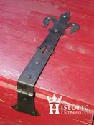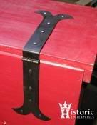
http://www.historicenterprises.com/cart.ph...duct_list&c=122
If you have pyrate kiddos.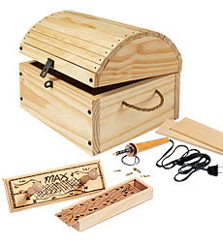
http://www.hearthsong.com/hearthsong/produ...rch%20Result|P1
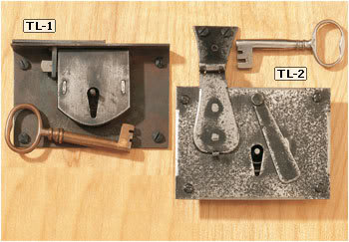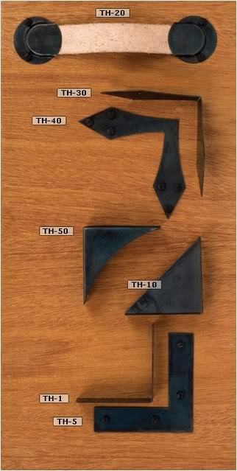
http://www.horton-brasses.com/products/loc...s/ironlocks/111
http://www.horton-brasses.com/products/chestlifts
http://www.horton-brasses.com/products/han...ronspecialty/66
More hand forged strap hinges:
http://www.oldsmithyshop.com/hinges.html
http://www.wildwesthardware.com/hinges/hinges.htm
http://www.montanahinge.com/hinges.htm
http://www.cowboyindian.com/adrustih.htm
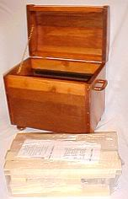
Smoke & Fire makes a kit for 'bout $50. (plus shipping).
http://www.smoke-fire.com/wood-items-furniture-1.asp

blackjohn
- Iron Age Hero Lost at Sea
- Member

- 3,745 posts
- Gender:Male
- Location:Columbia, Md
- Interests:Stuff... and junk.
Posted February 26, 2007 · Report post
CaptainSatan said:
There were no rules of fashion when it came to chests.
Actually, as I recall there are, sort of.

blackjohn
- Iron Age Hero Lost at Sea
- Member

- 3,745 posts
- Gender:Male
- Location:Columbia, Md
- Interests:Stuff... and junk.
Posted February 26, 2007 · Report post
CaptainSatan said:
kass said:
Remember: scholarly discussion of the GAoP...
Did you not read the name of this thread
Here are some links in case you want to build yer own
If you had posted this in Plunder I doubt anyone would have said one peep about it. In here, people like to discuss the deep dark details of things, preferably with some sort of supporting evidence.
That Smoke & Fire chest looks interesting. But just because a sutler sells it doesn't mean it is correct.
:)

CaptainSatan
- Notorious Pyrate
- Member

- 791 posts
Posted February 26, 2007 · Report post
blackjohn said:
If you had posted this in Plunder I doubt anyone would have said one peep about it. In here, people like to discuss the deep dark details of things, preferably with some sort of supporting evidence.
Were this thread meant for any serious discussion it would not mention the words treasure and chest in the same sentence.The concept of treasure chests is a fun part of pirate mythology.Attempting any serious scholarly discussion on a subject that is pure fantasy is like debating about Star Wars. They are both interesting subjects and they are both pure fiction.
-CS

CaptainSatan
- Notorious Pyrate
- Member

- 791 posts
Posted February 26, 2007 · Report post
blackjohn said:
That Smoke & Fire chest looks interesting. But just because a sutler sells it doesn't mean it is correct.
:)
That chest IS NOT period. But if you leave off the feet, replace the wooden handles with rope or metal, and use some hand forged nails you have something that would be very similar to surviving examples and chests depicted in art from the period.Even though it would not be based on a specific specimen it would never the less be true to the period. I have not seen the hinges for that chest, but they could be replaced as well.
-CS

Patrick Hand
- The sailor's sailor
- Moderator

- 6,100 posts
- Gender:Male
- Location:TH' Mountains of Central California
- Interests:I like wierdness... Klingon, Pyrate..... and even..... gasp.... Renn Faires...... (Baseball and tractor pulls I'd have to think about.... could be wierd or Not,,,,)
Posted February 26, 2007 · Report post
Quote
If you had posted this in Plunder I doubt anyone would have said one peep about it. In here, people like to discuss the deep dark details of things, preferably with some sort of supporting evidence.
Quote
Were this thread meant for any serious discussion it would not mention the words treasure and chest in the same sentence.
Quote
If you had posted this in Plunder
Sorry, Black John is right...... Fun Pyrate stuff gets posted in plunder, and discussions about real period stuff gets posted in Twill....
The easiest way to deal with this, is to just start another thread in Plunder all about Treasure Chest.... (that way the entire thread dosen't have to get moved...) The links to treasure chest hardware are good, and how to make one, and pictures of ones that have been made are all cool.... but if you post in Twill, expect to be asked about historical accuracy.......
Sure, it's kinda snobbish..... but if someone reads in Twill how to make or where to buy an "authentic" treasure chest (or bucket boots)....... Wellllll the debates are always fun to read......

oderlesseye
- Scourge o' the 7 Seas
- Member

- 2,126 posts
- Gender:Male
- Location:San Diego, Ca. (North Park) me cove !
- Interests:Oderlesseye is a mutinous two bit sand dollar with a thirst for adventure. Sailing on tall ships, firing black powder weapons, and sword fighting.. I most love to entertain the public in piratical skit presentations that involve all of the above. My name is befitting of my position on board as that of the look-out. Some ask what’s the meaning of the name Oderlesseye...It is simple really.. When Eye am aloft, ye can’t smell me...But it’s spelled wrong some exclaim! Hey now! What pirate can spell? - is my retort!
I have been an active member of the pirate community since 2005. I consider myself a fan of living history in the Golden Age of Piracy. As a child I , like the lot of ye, loved the old time pirate movies with Errol Flynn and Douglas Fairbanks. Long live Long John Silver !
Inspired by them, Eye created a Pirate Ninja Movie called "Treachery and a Dead Mans Promise" Available on YouTube.
Being a pirate, as it turns out, is multi-dimensional. For me, a lifestyle has been carved out of it. There is a six foot tall skeleton pirate in a make shift hide out called Dead Mans Cove behind my house. The walls are painted giving the impression you are in a sea cave. There is a mural of a pirate coming ashore in a long boat at the mouth of the cove. Believe me, it is a great place to enjoy rum now and again!
Exploration into all things piratical have led me to being an attempted escapee from the Governors noose to impersonating a judge in the Anne Bonnie and Mary Read trial held in Pirates In Paradise.. As Oderlesseye, my one on one impression to patrons is as one whom barley escaped the flames of the ship we took when the powder magazine blew with the booty in me hands from the Captains quarters.. The tale explains the soot on me face, the tattered clothing, and the burnt tricorn, as I hand out a gold coin or two. I hate them plastic ones and I know kids appreciate the metal coins even more so.
When an event is slated for a historical time line presentation to the public, I do not do these things mentioned above. Rather, I share about what is a grape shot or how a flintlock works. I ware clothing that is more closely representing the era in these cases. I am still updating me togs (Period Kit) as I learn more thru fellow pirates and sources like the Pyracy Pub.
So far, there have been many exciting moments of adventure the world of PIRACY has afforded me. From standing on a bar top with Pirates Charles singing to me in New Orleans to shooting cannons ( Ships Guns for you PC Pirates!), on the tall ship Spirit of Dana Point. Cheers from a crowd during a show as last man standing on the Treasure chest proclaiming to an excited crowd ITS MINE! THE BOOTY IS MINE ! YARR ! ~ These things and the notoriety that comes with being a pirate has me hooked! Whats More Is the greater bonds of friendships that have been forged with those whose course finds me at such events, sharing the same love and passion of the Life within the pirate/reenactment community. To Them Eye take me hat off and offer a tot of Rum! Cheers mates!
Posted February 27, 2007 · Report post
Vallejo Maritime Gallery ... is really cool.. EYE gotta go there..
Harbormaster please grant me to tell ye that period or not ... the chest ye has is indeed handsome and Eyes would like to come into posession of one...

Ol Man From the Sea
- Ship's Master
- Member

- 121 posts
- Location:1/2 degree on the 270 radial from da big city on the third coast
- Interests:Pirates in Paradise, Women Pirates and pirate's Women, GAoP, Small airplanes that I can fly in or tiny ones I fly indoors, Sailin', Drivin' ah heck just Goin'...
Posted February 27, 2007 · Report post
Captain Jim
Thank you for posting that beautiful captains chest. I learned a lot from that photo as it shows just about everything I was expecting not to see in a period seamans chest.
No beckets
Fine wood
Dovetails
Over lapping lid all around
Finaly, I realized that it is a Captains chest, which is to say not a seamans chest. I had read that Captains would have several chest in their cabin each with its purpose, but when I looked at chest I had not thought to be aware of the distinction.
As I am not a captain, at least not yet, I want info on seamans chest.
Although, I can see how a lowly pirate might get his hands on a captains chest. I bet no pirate ever left a captain's liquor chest behind. Who says treasure chest are hollywood. Just have to think about what pirates really treasured. :)

Ol Man From the Sea
- Ship's Master
- Member

- 121 posts
- Location:1/2 degree on the 270 radial from da big city on the third coast
- Interests:Pirates in Paradise, Women Pirates and pirate's Women, GAoP, Small airplanes that I can fly in or tiny ones I fly indoors, Sailin', Drivin' ah heck just Goin'...
Posted February 27, 2007 · Report post
CaptainSatan said:
That chest IS NOT period. But if you leave off the feet, replace the wooden handles with rope or metal, and use some hand forged nails you have something that would be very similar to surviving examples and chests depicted in art from the period.Even though it would not be based on a specific specimen it would never the less be true to the period. I have not seen the hinges for that chest, but they could be replaced as well.
Sorry captain but even with all those chages that chest still will not be period. I looked at their plans for one this weekend. The joinery is way off. To make anything close to a period chest you would need to remachine all or at least most of the wood. It would be as much or more work than starting from scratch. It would have been nice if it could be saved with a few small changes, but alas no.

CaptainSatan
- Notorious Pyrate
- Member

- 791 posts
Posted February 27, 2007 · Report post
Where did you see the plans? I'd like to take a looksie myself
And please be specific. Share your knowledge and expertise with the rest of the crew. I for one would like to know the details of the post period joinery you are refering to. I am very interested in whatever methods you are refering to that were never used to construct a wooden box before 1720.
-CS

CaptainSatan
- Notorious Pyrate
- Member

- 791 posts
Posted February 27, 2007 · Report post
Patrick Hand said:
Sorry, Black John is right...... Fun Pyrate stuff gets posted in plunder, and discussions about real period stuff gets posted in Twill....
That's kinda my point.I wasn't expecting a thread titled Chests, "Treasure" and otherwise to be posted with the real period stuff?
Anyway... my mistake, I saw the name of the thread and assumed that that it wasn't a serious discussion. I'll pay more attention to where it is posted next time
-CS

Captain Jim
- Captain Jim for Captain!
- Member

- 2,254 posts
- Gender:Male
- Location:Off the coast of Tampa Bay (Unfortunately, inland from the coast)
- Interests:I'm 57, formerly a wildlife ecologist and biologist, now a stay-at-home dad. I grew up on the west coast of Florida, where Anna Maria Sound and Tampa Bay were my playground. My interests include, but are not limited to cannon, black powder arms, history, fishing the flats, sailing, fine wood working, flint gun building, hunting, good gun dogs. Above all, my wife and children.
Posted February 27, 2007 · Report post
While this thread was posted under Twill and veered into the realm of "Hollywood" for a while, it is still useful in showing what was probably not used during this period.
Actually Selkirk (whose chest I posted) was sailing master for William Dampier on the privateer Cinque Ports and was voluntarily marooned on the island of Juan Fernandez in 1704 after disagreeing with the captain over the seaworthiness of the Cinque Ports. He was rescued four years and four months later by the privateer Duke commanded by Woodes Rogers whose pilot was…William Dampier. Pirates everywhere.
Your typical sea chest at the time was more that likely not uniform in any meaningful way. Some would have been an old crate or even a barrel. Later, during the Golden Age of Whaling, more uniform chest types were quite common. Here, from Marilinespike.com, is an example of a whaler’s type chest, of which many original examples are available on the antique market.
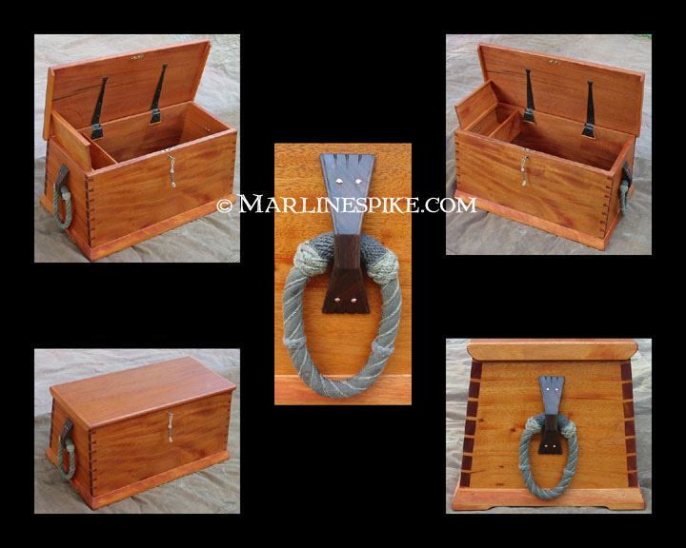
We have also seen one example of such a chest in a period painting depicting a harbor/dock scene (Ludolf Backhuysen, Dutch, 1673, among the baggage in the foreground).
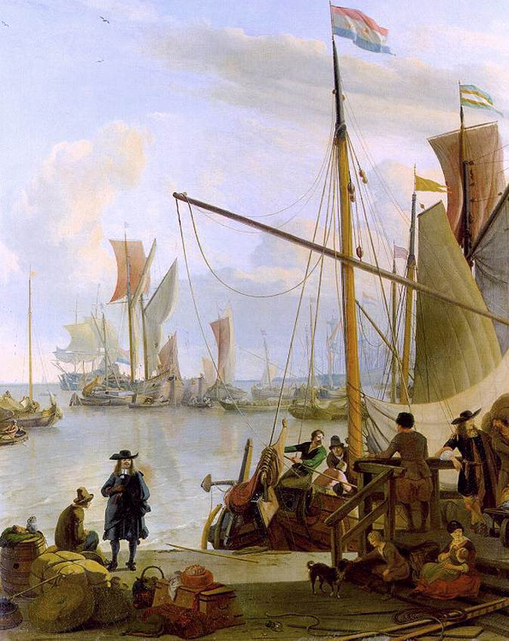
So is it period? It was probably uncommon, and almost certainly did not have the intricate beckets that are one of the hallmarks of the whaling chest, but an argument could be made for its use in its plainer form.
Otherwise any well constructed chest-type box should be acceptable, with attention paid to regional and period styles, which is why knowing where and when those chests posted earlier were built is critical.

CaptainSatan
- Notorious Pyrate
- Member

- 791 posts
Posted February 27, 2007 · Report post
Aaahhh...thank you so much for posting that painting!
There are so many surviving examples and replicas of that type of chest, but the vast majority are from the mid 19th century.It's such a practical design because its hard to tip over on rough seas ( or the back of a Jeep).I am very pleased that there is documentation to place that basic design in TGAoP.
I especially like the fact that the corners are bound in iron. That would be a lot less work than dovetails.
Cheers!
-CS

Captain Jim
- Captain Jim for Captain!
- Member

- 2,254 posts
- Gender:Male
- Location:Off the coast of Tampa Bay (Unfortunately, inland from the coast)
- Interests:I'm 57, formerly a wildlife ecologist and biologist, now a stay-at-home dad. I grew up on the west coast of Florida, where Anna Maria Sound and Tampa Bay were my playground. My interests include, but are not limited to cannon, black powder arms, history, fishing the flats, sailing, fine wood working, flint gun building, hunting, good gun dogs. Above all, my wife and children.
Posted February 27, 2007 · Report post
Angled dovetails or, harder yet, compound angled dovetails.

CaptainSatan
- Notorious Pyrate
- Member

- 791 posts
Posted February 27, 2007 · Report post
I'm quite happy to stick with nails, pegs, n' iron straps
I suppose those are simple rope handles attached to two pairs of holes on the sides of the chest.
Speaking of beckets...
I was researching an earlier period chest from the Mary Rose(English,built 1509-1511, sank in 1545). And I noticed a very simple 6 board chest that had cleats like those on later period chests for attaching beckets.Something else unusual 'bout that chest was the fact that it was dove tailed (somewhat uncommon for an English chest of the period). I can't help but wonder if that particular chest was liberated from a sea-frog or aquired eslewhere on the continent. Another thing unusual was the fact the chest was constructed of pine, walnut, and poplar. I'm just speculating here, but I suspect that chest was constructed out of scraps, yet someone took the time to dovetail the edges using 16th century tools.
~CS

kass
- Scourge o' the 7 Seas
- Member

- 1,526 posts
- Gender:Male
- Location:Easton, Pennsylvania
- Interests:Historical Clothing from the 14th through 18th centuries. Getting all the niggling details right. Dressing up and having fun with my similarly-obsessed friends. :)
Posted February 27, 2007 · Report post
Captain Jim said:
While this thread was posted under Twill and veered into the realm of "Hollywood" for a while, it is still useful in showing what was probably not used during this period.
Which is why your intrepid moderator has not deleted it, Jim. :)
In future, Satan, if you want to discuss "fun Pyrate" stuff, it doesn't belong here.
But I'm glad this thread has come around to what IS appropriate for the period. Thank you, woodworking specialists!

CaptainSatan
- Notorious Pyrate
- Member

- 791 posts
Posted February 27, 2007 · Report post
kass said:
In future, Satan, if you want to discuss "fun Pyrate" stuff, it doesn't belong here.
That would be Captain Satan to you love
...and as I mentioned earlier I was responding to the Hollywood title of this thread. Had it been titled Sea Chests my first shot across the bow would be carbon dating wood fragments , impurities in period nails, and the deforestation of Ireland and it's impact on early 17th century English carpentry
But seriously....now that I know the rules I promise to play nice.
-CS

CaptainSatan
- Notorious Pyrate
- Member

- 791 posts
Posted February 27, 2007 · Report post
Back to the subjects of chests...
I'm interested to know when barrel top, or humped lid chests began to be constructed out of multiple boards. The earlier chest lids were hewn out of a single piece of wood that was round on top and hollowed out underneath. The earliest example that I've found is in Hereford Cathedral in the UK. The best date that I have is sometime in the 15th century.Rather unusual for a iron bound chest of pine to actually last 600 years.
If you know of any art from TGAoP that depicts a chest with a round lid made of multiple boards please post it here. Ditto for any surviving examples. I know that multiple board lids and single piece hewn lids both existed during TGAoP. What I would like to know is, when did the multiple board lids FIRST appear?
Inquiring minds want to know
Any of you hardcore reenactors able to shine your double candle ships lantern on this subject ???
-CS

Patrick Hand
- The sailor's sailor
- Moderator

- 6,100 posts
- Gender:Male
- Location:TH' Mountains of Central California
- Interests:I like wierdness... Klingon, Pyrate..... and even..... gasp.... Renn Faires...... (Baseball and tractor pulls I'd have to think about.... could be wierd or Not,,,,)
Posted February 27, 2007 · Report post
Marlinespike.com sells plans on how to make the sea chest, I think William posted eairlier that he bought a copy. A review would be kinda nice.....
I know that wide pine boards use to be much more common than they are now.... so a period chest wouldn't have to use glued together boards...
I'm still trying to figure out the dementions that I want to use to make one.... But unfortunatly, there are some modern considerations that I will have to factor in (such as could I take it on an airplane.... Pyrates didn't have to worry about that...)
I'm also wondering about the backets.... maybe not as complex as on latter period chest, but handles to move the thing seem to be a must.... there are some post (I think) in Plunder on how to make them......
Right now, I'm just looking for references and such, it won't be untill later that I get around to actully making it.... The biggest hastle in this pre-planning stage is trying to decide how much to modify it's size (and exactly what form of jointery I will use....) Do I make a sea chest that is period dementions, but I can only use localy, or how much do I cheat and make something that I can use for PiP.......but still is a semi-period sea chest......

blackjohn
- Iron Age Hero Lost at Sea
- Member

- 3,745 posts
- Gender:Male
- Location:Columbia, Md
- Interests:Stuff... and junk.
Posted February 27, 2007 · Report post
CaptainSatan said:
What I would like to know is, when did the multiple board lids FIRST appear?
This first time someone had to piece together a lid because it was less than the price of a single board?
Remember. Here, in the colonial era, all the huge trees had yet to be felled. The floorboards in the oldest house in Cape Cod are immense!

Patrick Hand
- The sailor's sailor
- Moderator

- 6,100 posts
- Gender:Male
- Location:TH' Mountains of Central California
- Interests:I like wierdness... Klingon, Pyrate..... and even..... gasp.... Renn Faires...... (Baseball and tractor pulls I'd have to think about.... could be wierd or Not,,,,)
Posted February 27, 2007 · Report post
Not Sea chest..... but from Building Classic Small Craft by John Gardner.
Quote
New England dories came into being when native lumber was plentiful and cheap, when beautiful clear boards of northern white pine 14 inches, 15 inches and even 18 inches wide were to be had for a few cents a board foot
And that was after the GAoP..........

CaptainSatan
- Notorious Pyrate
- Member

- 791 posts
Posted February 27, 2007 · Report post
blackjohn said:
This first time someone had to piece together a lid because it was less than the price of a single board?
Yes but when did that happen? More importantly when can that be documented. And remember not all chests would have been built in the colonies.The chest I was discussing from the Mary Rose seemed to be made from scraps in England or Europe.Again I am speculating, but I suspect that multiple boards on a round lid were the result of new wood working techniques rather than a shortage of materials.
From my personal experience making Dark Age furniture I can tell you that hewing out a tree trunk is a lot more labour intensive than making something from pre-cut boards.Unless you are making a strong box , I can't think of any advantage to making a curved lid from a solid block of wood with an adze.
-CS

CaptainSatan
- Notorious Pyrate
- Member

- 791 posts
Posted February 27, 2007 · Report post
Patrick Hand said:
Marlinespike.com sells plans on how to make the sea chest, I think William posted eairlier that he bought a copy. A review would be kinda nice.....
I know that wide pine boards use to be much more common than they are now.... so a period chest wouldn't have to use glued together boards...
"The Sea Chest, History and Construction Plans", written and illustrated by Tim Whitten, details traditional sea chest construction methods. Included are dimensions and details unique to the typical slanted seamans chest as illustrated in the finished models shown below. The book is 24 pages and plastic bound to allow it to lay flat. Also contains sources for hard to find materials such as hand forged hinges and wide board lumber. $12 plus shipping.
http://www.marlinespike.com/sea_chests.html
I had seen that book but I mistakenly thought those chests were all post period. Since Captain Jim has enlightened me on the subject I will order a copy tonight
And you are correct Mr. Hand! Wider boards will give you a more period look. If I am going to go to the trouble & expense of having boards custom millled I will probably go ahead and go with a hardwood myself.I may make a low cost PROTOTYPE out of plywood. By the time it received a few coats of sanded milk paint it would look good in the background (slightly out of focus) for some of my pyrate photos. Since it wouldn't be period I would probably donate it to a pyratee kid to use as a toy chest. Maybe it's that wacky perfectionist gene, but I like to play with low cost mockups before I start cutting & drilling those expensive custom milled boards.
-CS
More sea chest plans http://classicseachests.com/contact_us.htm
-

CaptainSatan
- Notorious Pyrate
- Member

- 791 posts
Posted February 28, 2007 · Report post
Ok here is a closeup of the sea chest from around 1673.
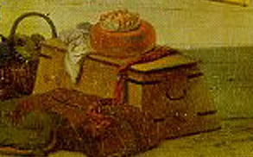
It does not appear to be joined by dovetails, nor does it feature cleats and fancy beckets. I can't see a lot of detail but it appears to have an over hanging lid like the later period chests.
-CS
PS: I'm working on getting y'all a copy of the mysterious Mary Rose chest that I keep talking about.If nothing else I have some hard copies somewher in my office.

CaptainSatan
- Notorious Pyrate
- Member

- 791 posts
Posted February 28, 2007 · Report post
And here are some pretty pictures of the mid 19th century or classic sea chest. These chests were made by Classic Sea Chests & Display Boats.
The dimensions are 39 inches by 19 inches by 16-5/8 inches high. The chests in pine weigh approx 45 lbs. You can see even better pictures by visiting their website.
http://classicseachests.com/
You'll notice that these later period chests have a similar (but more subtle sloping) shape as the chest pictured in the 17th century painting. Unlike the earlier chest, these examples feature wooden cleats on the sides of the chest for simple rope handles. They have dovetail joints and some reinforcing around the the bottom exterior edge.The little brass hinges are obviously way too modern and the black tape on rope handles needs to go, the dog tag chain on the lid should be replaced as well. While I don't have any hard eveidence to back it up.I do suspect that the simple rope handles eyed through the cleats would be closer to the period than the fancy beckets we see on 19th century chests.
While the 1763 chest does not have any visible dovetailed joints or cleats, the chest found on the Mary Rose posseses both of these features.And that chest was made AT LEAST 128 years before the one in the painting. So it's quite possible that the mid 19th century style may be more period than they first appear. Remember the chest in the painting is only one example.
-CS
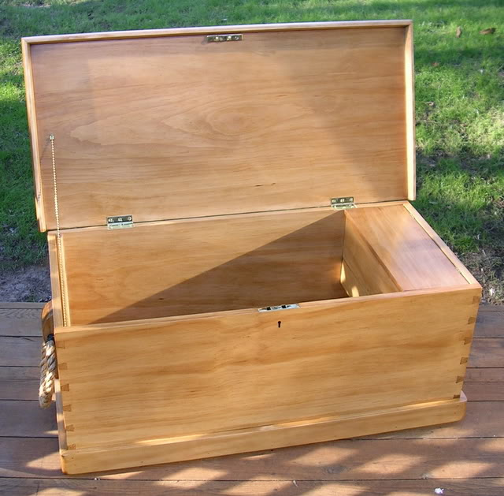
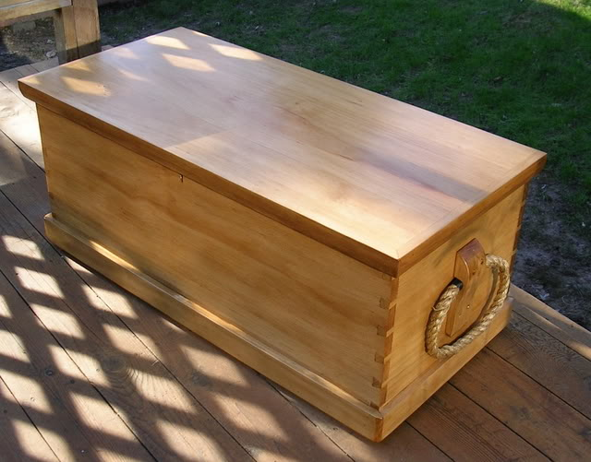
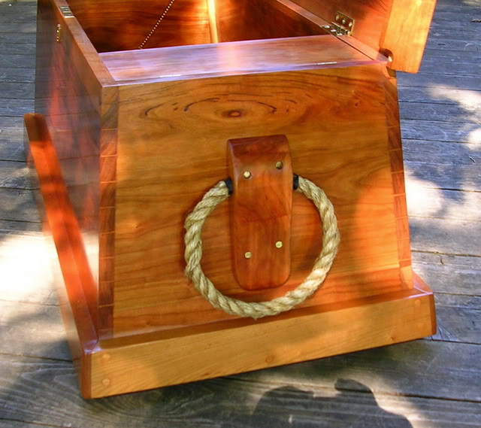
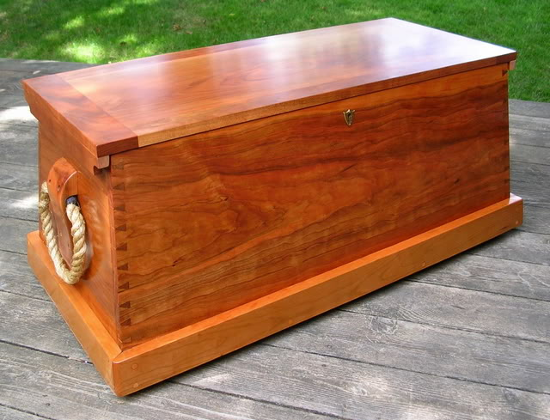
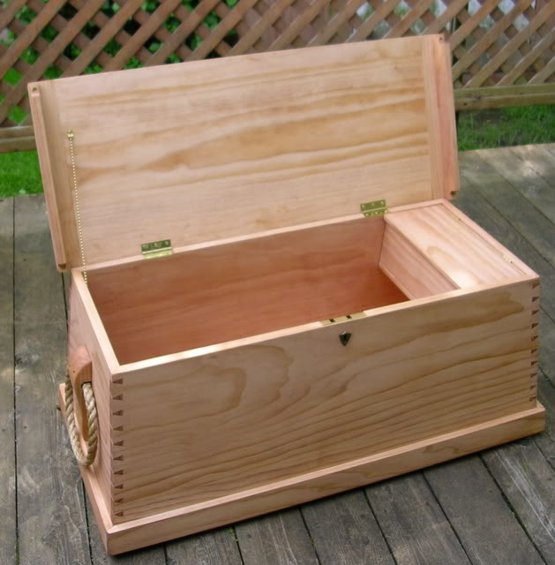
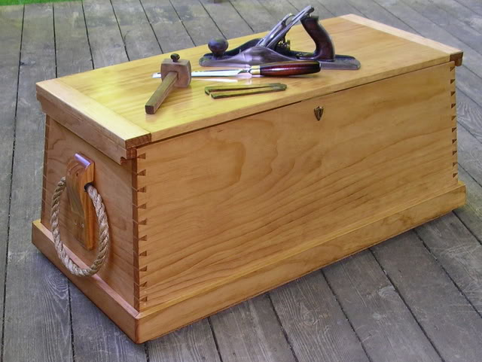

CaptainSatan
- Notorious Pyrate
- Member

- 791 posts
Posted February 28, 2007 · Report post
blackjohn said:
CaptainSatan said:
What I would like to know is, when did the multiple board lids FIRST appear?
This first time someone had to piece together a lid because it was less than the price of a single board?
Remember. Here, in the colonial era, all the huge trees had yet to be felled. The floorboards in the oldest house in Cape Cod are immense!
Please keep in mind that you can't make a TRADITIONAL barrel/humped lid from a single board. To make it out of a single piece of wood you would need something like a split tree trunk.
-CS

blackjohn
- Iron Age Hero Lost at Sea
- Member

- 3,745 posts
- Gender:Male
- Location:Columbia, Md
- Interests:Stuff... and junk.
Posted February 28, 2007 · Report post
I suspect if someone wanted to they could. Warping wood isn't all that difficult.
A previous sea cheast thread:
http://pyracy.com/forums/index.php?showtopic=5771

CaptainSatan
- Notorious Pyrate
- Member

- 791 posts
Posted February 28, 2007 · Report post
" Warping wood isn't all that difficult."
But are there any examples of pirate era chests that were built that way?
-CS
PS.
Here are some pictures of a lid made from a single peice of wood and one made of multiple boards. I'm not including any documentation because I just want to illustrate the two different styles. The first two images are a reproduction of a Viking Age chest.
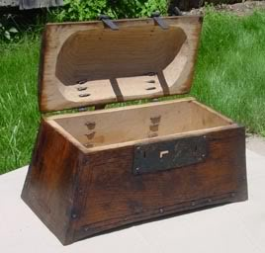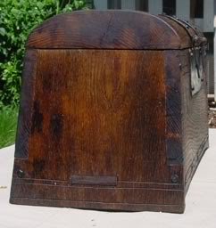

CaptainSatan
- Notorious Pyrate
- Member

- 791 posts
Posted February 28, 2007 · Report post
Here is a mid 18th century pine sea chest. It was probably made about 30 years after TGAoP. I can see nothing in the actual design that is post period.You could also reconstruct a similar chest using iron brackets on the corners instead of dovetail joints.
18.5" wide, 45" long (on the top), and 20" high.
Note the nails in the cleats, the over lapping lid, and the large dovetails.
-CS
