crimson corsair
- First Mate
- Member

- 250 posts
- Location:Elkridge,Maryland
- Interests:Hunting ,fishing.Camping,doing pirate stuff.....
Posted July 20, 2011 · Report post
I smoke cigars. I would like to know if anyone knows at what point did cigars come in to the picture? can I have on around the camp and be period? If so does anyone have any idea what a GAOP cigar may looked like?
Thanks for any help you can give.
CC.

Mission
- Goat Specialist
- Admin

- 5,082 posts
- Gender:Male
- Location:Monroe, MI
- Interests:Scholarly piracy, designing and creating haunted house rooms and props, movies, abstract thinking, abstruse thinking, obstructive thinking, ideating, random thinking, movies, cartoons, movies, movies scores, cycling, world peace and small furry dogs, movies, writing, drawing, personal skills training, gremlins and, of course, lest I forget, movies.
Posted July 20, 2011 · Report post
According to this page, it doesn't sound like cigars would have been preferred during our period, although they existed.
"Cigars, more or less in the form that we know them today, were first made in Spain in the early 18th century, using Cuban tobacco. At that time, no cigars were exported from Cuba.
By 1790, cigar manufacture had spread north of the Pyrenees, with small factories being set up in France and Germany.
The Dutch, too, started making cigars using tobacco from their Far Eastern colonies. But cigar smoking only became a widespread custom in France and Britain after the Peninsular War (1808-14), when returning British and French veterans made fashionable the habit they had learned while serving in Spain.
Production of "segars" began in Britain in 1820, and in 1821 an Act of Parliament was needed to set out regulations governing their production. Because of an import tax, foreign cigars in Britain were already regarded as a luxury item."
"Early 18th century" is sort of vague, but even if it was really early, it still would have been at the end of the Golden Age of Pyracy. Since the British were at war (on and off) with the Spanish during the GAoP, I don't think they would have readily adopted a lot of Spanish customs. Although pirates were sea-faring, their behaviors were probably still primarily rooted in those of their home countries. They might have gotten cigars from Cuba, although, again, this was Spanish-held and probably not a welcome place for pirates.
So, if all that info is correct, I don't think cigars would have been the norm among the people who were typically pirates (the French, British, Dutch, Germans, Scottish, Irish and Americans - among others - see this thread for more on pirate nationalities) until after 1790.

Daniel
- Pyrate Captain
- Member

- 652 posts
- Gender:Male
- Location:McLean, VA
- Interests:History, pirates, fiction, writing, writing historical fiction about pirates, jokes, games, law.
Posted July 20, 2011 · Report post
But Philadelphia passed a law in 1683 forbidding "smoking seegars on the street." Dan Ahrens, Investing in Vice, p. 83. It was apparently common enough to be a fire hazard, because the fines were used to buy firefighting equipment. So I would say yes, a cigar would be period, although I don't have anything to show how cigars then differed from cigars now.

Mission
- Goat Specialist
- Admin

- 5,082 posts
- Gender:Male
- Location:Monroe, MI
- Interests:Scholarly piracy, designing and creating haunted house rooms and props, movies, abstract thinking, abstruse thinking, obstructive thinking, ideating, random thinking, movies, cartoons, movies, movies scores, cycling, world peace and small furry dogs, movies, writing, drawing, personal skills training, gremlins and, of course, lest I forget, movies.
Posted July 20, 2011 · Report post
On 7/20/2011 at 1:01 PM, Daniel said:
But Philadelphia passed a law in 1683 forbidding "smoking seegars on the street." Dan Ahrens, Investing in Vice, p. 83. It was apparently common enough to be a fire hazard, because the fines were used to buy firefighting equipment. So I would say yes, a cigar would be period, although I don't have anything to show how cigars then differed from cigars now.
If the website I cited is correct (and I don't know that it is or isn't), I wonder where they came from? Were the colonists making them from the tobacco they grew? You would think there would be an industry would build up around it if there were. It might suggest a hand-rolled look.
Although just because a law was made doesn't necessarily mean the practice was common. There may have been a situation like we sometimes have today where one event caught the public's attention and led to the passing of a law with the idea that it would prevent future possible occurrences, sate the public ire and perhaps even make the lawmaker look good in the process. ('Caylee's Law' comes to mind...) Maybe someone managed to smuggle some out from Cuba on their way to the colonies and set fire to the squib-making factory.

Ivan Henry aka Moose
- Plunderer
- Member

- 486 posts
- Gender:Male
- Location:tampa, fl
- Interests:Bicycles
Travel
Wine
Beer
Good Food
Pizza!
Pirate Stuff
Design
Posted July 28, 2011 · Report post
In my ramblings through period paintings and drawings, I have seen a lot of pictorial evidence for pipes and tobacco but zero for cigars. If anyone has any, I would love to see it.

Korisios
- Pyrate Captain
- Member

- 565 posts
- Gender:Male
- Location:Netherlands
- Interests:Celts BC, Guatemala, Pirats
Posted January 16, 2012 · Report post
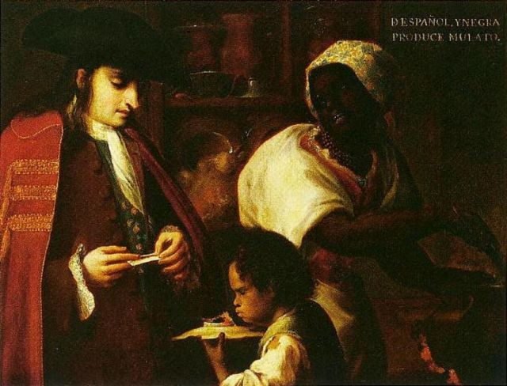
I have two casta paintings from 1725, one shows a men rolling his own cigaret that I would rather call a "papelito" or "pepelete" according to a book I have about smoking.
The other casta painting shows a man smoking a small cigar. Both pure Spanish men if i'm not mistaking. The book also tells that in the early 18th century such small cigars or papelitos where also made in Mexico, like they where in Sevilla at that time... Dispite the two casta painings showing smoking men, the book also states that these small cigars where more considered to be for woman...

jendobyns
- Pyrate Captain
- Member

- 562 posts
- Gender:Female
- Location:Baltimore
- Interests:too numerous to mention, really. Period foodways, baroque dance, material culture, etc., etc.
Posted January 16, 2012 · Report post
Could you tell us more about the book? Title, author, isbn? It sounds like a great reference.

Johnathan Atwood
- Deck Swabber
- Member

- 40 posts
- Gender:Male
- Location:Isle of Rhodes
- Interests:Sailin', Stabbin', Shootin'
Posted January 27, 2012 · Report post
I have read that small cigars and papelitos are period accurate from several online sources as well as the book Smoke: A Global History of Smoking by Sander L. Gilman. I have also spoken at length with several knowledgable tobacconists on the subject.
The general consencus is that Men prefered to use pipes. There is a TON of archiological and written evedince to back smoking of pipes. As for Cigars, there was a law in both Philidelphia and Massachusetts in 1683 banning them, and a general law banned smoking in all forms outdoors in Plymouth Colony as early as 1632.
The first industrial manufactured cigars would not appear in North America until the 1760's, but hand rolled will work for GAoP.
As to the assertion that papelitos were considered feminine, I have heard it as rumor but have not read of it. I guess it is up to you to decide.
If you decide you wish to take up a pipe instead I would recommend either a clay pipe that you can easily replace once you've broken it (because you will), or a wooden one with a copper or brass cover for the bowl. There is writen documentation from the GAoP about these being the only acceptable pipes to be smoked below decks. Also, look for a sailor's cut or rough cut tobacco when purchasing tobacco for events. This is a longer, more solid cut that one needs to "rub out" in order to make it pack well into your pipe. It is also the closest you can find to what was available at the time.

