Pulleys
Started by Captain Jim, December 11, 2006

- • • •

12 posts in this topic

Captain Jim
- Captain Jim for Captain!
- Member

- 2,254 posts
- Gender:Male
- Location:Off the coast of Tampa Bay (Unfortunately, inland from the coast)
- Interests:I'm 57, formerly a wildlife ecologist and biologist, now a stay-at-home dad. I grew up on the west coast of Florida, where Anna Maria Sound and Tampa Bay were my playground. My interests include, but are not limited to cannon, black powder arms, history, fishing the flats, sailing, fine wood working, flint gun building, hunting, good gun dogs. Above all, my wife and children.
(IP: 207.96.50.26) ·
Posted December 11, 2006 (edited) · Report post
Simple question here. While standing rigging of this time was usually deadeye tackle, the tensioning devices used to set them up and to hoist cargo were block and tackle pulley combinations. The question is whether they were iron bound or rope bound in the late GAoP ca. 1720, or if both were being employed at that time.
And yes, I know they are called blocks on a ship. Used pulley to help avoid confusion and interest the non-nautical.
Planning to work some up for pyrate camp.
Thanks in advance for your help and feedback, O Knowledgeable Ones.
Edited December 11, 2006 by Captain Jim

- Quote
- Edit

Fox
- Old Twillian
- Moderator

- 2,567 posts
- Gender:Male
- Location:Beautiful lush Devon, England
- Interests:Nautical history of the 16-18th centuries and living history based thereon.
Shooting pirates.
(IP: 217.42.78.123) · ·
Posted December 11, 2006 · Report post
I've not seen iron eyed blocks as early as the GAoP, but I ain't seen all of them. Rope is definitely period safe, and much prettier anyway.
The difference between "block" and "pulley" is not just a matter of being on a ship or not:
Pulley: 1. A simple machine consisting essentially of a wheel with a grooved rim in which a pulled rope or chain can run to change the direction of the pull and thereby lift a load.
Block: 5. a. A pulley or a system of pulleys set in a casing.
(thefreedictionary.com)

- Quote
- Edit
- Options

Captain Jim
- Captain Jim for Captain!
- Member

- 2,254 posts
- Gender:Male
- Location:Off the coast of Tampa Bay (Unfortunately, inland from the coast)
- Interests:I'm 57, formerly a wildlife ecologist and biologist, now a stay-at-home dad. I grew up on the west coast of Florida, where Anna Maria Sound and Tampa Bay were my playground. My interests include, but are not limited to cannon, black powder arms, history, fishing the flats, sailing, fine wood working, flint gun building, hunting, good gun dogs. Above all, my wife and children.
(IP: 12.195.96.35) · ·
Posted December 11, 2006 · Report post
I like the rope-bound ones as well, I just couldn't exclude iron bound. I'll go with rope also because my 'smith skills are still developing.
Meanwhile, in all my years at sea I have never heard a pulley called anything other than a block, including an individual single sheave variety. That of course is the sea lexicon which has been known to conflict with the lubber version. You know, port (larboard in our period) and starboard instead of left and right, stern not rear, below instead of downstairs, head and not bathroom, deck and not floor, cabin sole and not floor etc.
Although the "casing" part of the difinition would seem to indicate the sides (cheeks), not always present in openwork all-iron pulleys.

- Quote
- Edit
- Options

Dorian Lasseter
- Where's My Water
- Member

- 3,266 posts
- Gender:Male
- Location:The Sea!
- Interests:18th Century reenactment; Maritime, F&I...
Did ECW as well...
All BP firelocks and cannons!
Also enjoy Swordfighting and a good Donnybrook
Got a question for or about me? Ask!!!
(IP: 12.161.44.238) · ·
Posted December 11, 2006 (edited) · Report post
If the gods be willin' I'll bring these to PIP next year, and to any other event I remember to bring them to...
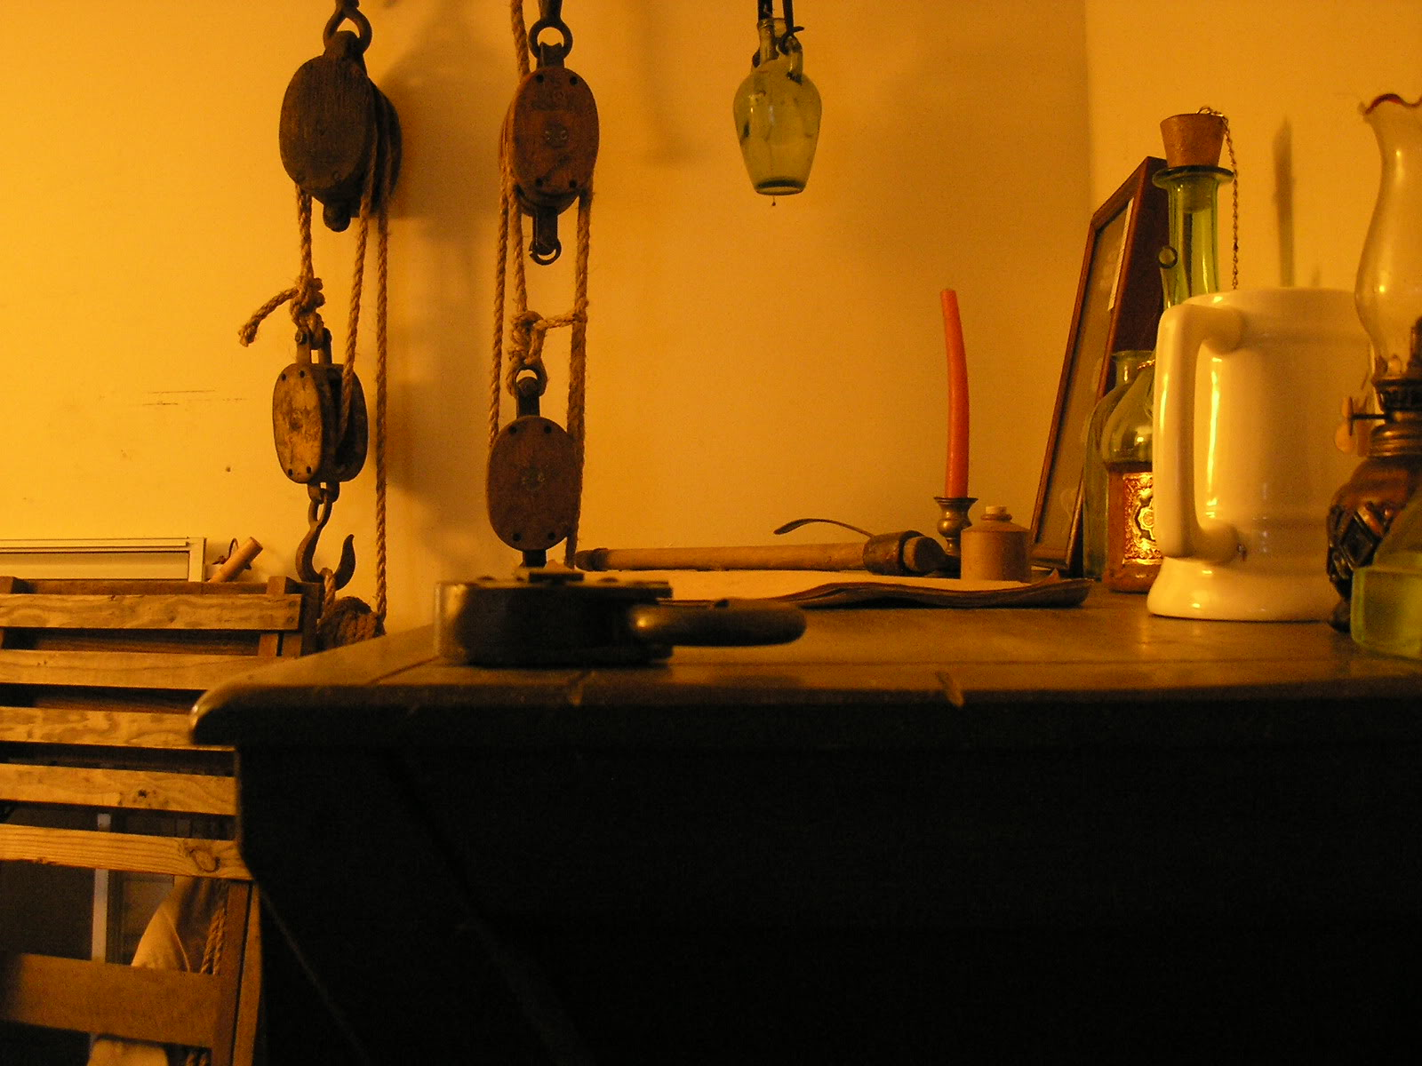
Sorry for the image size, but I wanted to show the detail... the line on them is 3/4" or so... something I had layin' about....
Edited December 11, 2006 by Dorian Lasseter

- Quote
- Edit
- Options

JohnnyTarr
- Dread Pyrate
- Member

- 1,082 posts
- Location:Kohler, WI
- Interests:Sailboats, sailing, Geocaching, beer and wine making, cartography, weapon fighting, fiddle.
(IP: 24.180.166.208) · ·
Posted December 12, 2006 · Report post
What is a rope bound block? I am tring to learn as much as I can, this question stumped me as to what you were even talking about. So here is a chance to learn even more.

- Quote
- Edit
- Options

Captain Jim
- Captain Jim for Captain!
- Member

- 2,254 posts
- Gender:Male
- Location:Off the coast of Tampa Bay (Unfortunately, inland from the coast)
- Interests:I'm 57, formerly a wildlife ecologist and biologist, now a stay-at-home dad. I grew up on the west coast of Florida, where Anna Maria Sound and Tampa Bay were my playground. My interests include, but are not limited to cannon, black powder arms, history, fishing the flats, sailing, fine wood working, flint gun building, hunting, good gun dogs. Above all, my wife and children.
(IP: 207.96.50.26) · ·
Posted December 12, 2006 (edited) · Report post
This is a rope bound or rope stropped block:
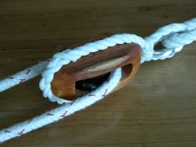
Illustration found here.
You should also take a look here.
The ones Dorian posted are iron stropped or bound.
In both cases other ropes/blocks are attached by the stropping. On the rope ones the rope also serves to keep the axle from backing out. Often there is a plate of brass over the ends of the axle openings to prevent this as well, often times decorative (I have no pictures of that though.) With the rope ones the weight of the axle is borne by the wooden cheeks. With the iron ones the axle rests internally on the iron stropping and the wooden outer cheeks help to prevent chafe and snagging on sails.
Edited December 12, 2006 by Captain Jim

- Quote
- Edit
- Options

Fox
- Old Twillian
- Moderator

- 2,567 posts
- Gender:Male
- Location:Beautiful lush Devon, England
- Interests:Nautical history of the 16-18th centuries and living history based thereon.
Shooting pirates.
(IP: 86.144.57.13) · ·
Posted December 12, 2006 · Report post
Captain Jim said:
Although the "casing" part of the difinition would seem to indicate the sides (cheeks), not always present in openwork all-iron pulleys.
You've hit the nail on the head there:
A sheave is the round wheel with a groove on the outside. Stick an axle through the hole in the middle of a sheave and you have created a simple machine, the pulley, which can be attached to all sorts of things. If you put the pulley (or more than one pulley) in its own casing you have created a block. A pulley used as an integral part of a different machine would remain a pulley, and not a block.

- Quote
- Edit
- Options

Captain Jim
- Captain Jim for Captain!
- Member

- 2,254 posts
- Gender:Male
- Location:Off the coast of Tampa Bay (Unfortunately, inland from the coast)
- Interests:I'm 57, formerly a wildlife ecologist and biologist, now a stay-at-home dad. I grew up on the west coast of Florida, where Anna Maria Sound and Tampa Bay were my playground. My interests include, but are not limited to cannon, black powder arms, history, fishing the flats, sailing, fine wood working, flint gun building, hunting, good gun dogs. Above all, my wife and children.
(IP: 207.96.50.26) · ·
Posted December 12, 2006 · Report post
And since pulleys on early ships would almost certainly have been universally enclosed within wooden cheeks, they would universally have been called blocks. Works for me.

- Quote
- Edit
- Options

MorganTyre
- First Mate
- Member

- 291 posts
- Location:South Texas
- Interests:Sailing, rigging, snorkeling, spearfishing, diving
(IP: 24.175.239.49) · ·
Posted December 12, 2006 · Report post
This may not extend to traditional rigging but in the modern vernacular sheaves that aren't in a block but do serve as a pulley are just called sheaves - such as the masthead sheaves a halyard runs through. In traditional terminology (nevermind about as far back as GAoP) would one refer to this sort of arrangement as a pulley?

- Quote
- Edit
- Options

Coastie04
- Dread Pyrate
- Member

- 1,008 posts
- Gender:Male
- Location:Juneau, AK
- Interests:Nautical history, sailing (especially tall ships and my own 'Sanctioned Mistress'), shooting (of all eras and calibers), and homebrewing.
(IP: 66.58.246.44) · ·
Posted December 12, 2006 · Report post
In the GAoP, they didn't put haliards through the masts (at least in no examples I've seen or heard of). The haliard would go to a block tied on to the mast, and then down one side of it. I'd imagine that cutting a slot for a pully (if that's what we'll call it) would weaken a wooden mast too much, or be too much work on the bigger masts. I know on later period vessels (such as CGC Eagle) that have hollow steel spars, a chain is attached to the yard that then goes through the mast on a pully and is shackled to a length of rope that continues the haliard to the belaying pin. However, I'm pretty certain that type of arrangement is out of period.
Coastie

- Quote
- Edit
- Options

Captain Jim
- Captain Jim for Captain!
- Member

- 2,254 posts
- Gender:Male
- Location:Off the coast of Tampa Bay (Unfortunately, inland from the coast)
- Interests:I'm 57, formerly a wildlife ecologist and biologist, now a stay-at-home dad. I grew up on the west coast of Florida, where Anna Maria Sound and Tampa Bay were my playground. My interests include, but are not limited to cannon, black powder arms, history, fishing the flats, sailing, fine wood working, flint gun building, hunting, good gun dogs. Above all, my wife and children.
(IP: 12.195.96.35) · ·
Posted December 12, 2006 · Report post
Before hollow masts any hoisting was done by blocks attached to the mast, crosstrees, etc. sheaves are the actual "wheel" that is the heart of the pulley. Built into the mast there are no other parts but the sheave and the axle or pin.

- Quote
- Edit
- Options

MorganTyre
- First Mate
- Member

- 291 posts
- Location:South Texas
- Interests:Sailing, rigging, snorkeling, spearfishing, diving
(IP: 24.175.239.49) · ·
Posted December 12, 2006 · Report post
Yes I know that a sheave in a spar is WAY out of period - that's why I specified "nevermind GAoP" I was just curious about the term pulley in traditional rigging (and a slot cut into a spar - especially a dumb sheave in a small boat masthead goes way back) as it's more or less absent from modern rigging terminology.
As a side note about dumb sheaves (for those who don't know) - this is a hollow groove cut into the end of a solid spar. The line bears directly on the wood and there are no moving parts, hence LOTS of friction so it's effective only for small rigs such as a shoulder-of-mutton on a Jolly-boat in which case it would be appropriate for it's simplicity, ease of stowage and maintenance and bulletproof reliability. Though I have no direct evidence of this extending back into the GAoP it's simplicity (far more so than a block) leads me to believe the idea is probably pre-biblical.
Incidentally, thanks for the links on the rope stropped blocks. Very cool.

