Jack Roberts
- Dread Pyrate
- Member

- 1,063 posts
- Gender:Male
- Location:Orlando, FL
(IP: 97.103.245.165) ·
Posted February 1, 2012 (edited) · Report post
Ok so here I'm going to show how I'm making a simple Brandy Punch.
Fairly common for our time period in England. It's called Major Bird's Brandy Punch Ingredients for are:
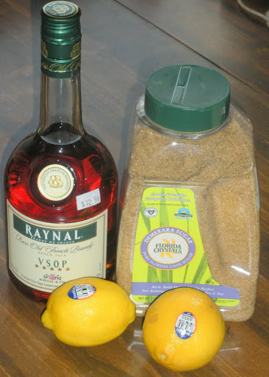
2-----------------Lemons
1/2 cup---------- Raw Sugar I'm using Florida Crystals
1/2 Quart (16oz) - Brandy
1 Quart ---------- Water
It seems that Rum would have been more common in the colonies. Limes were also used but considered somewhat inferior but being plentiful in the Carribean, were also used there and in the colonies.
The receipe is from "Punch" by David Wondrich and is our kind of writer. He's pulled from as many period resources as possible. In the back of the book he claims Google Books for a references. Sweet! He also is of the opinion that the spirits were stronger in alcohol than today and varied much. He also prefaces that because of this punches would have to be tailored to fit the quality of ingredients.
So on with the start of making a punch. This is half of the normal recipe, cause they're is only 2 of us.
Begin with peeling your Lemons avoiding as much pith as possible. I used a vegetable peeler.
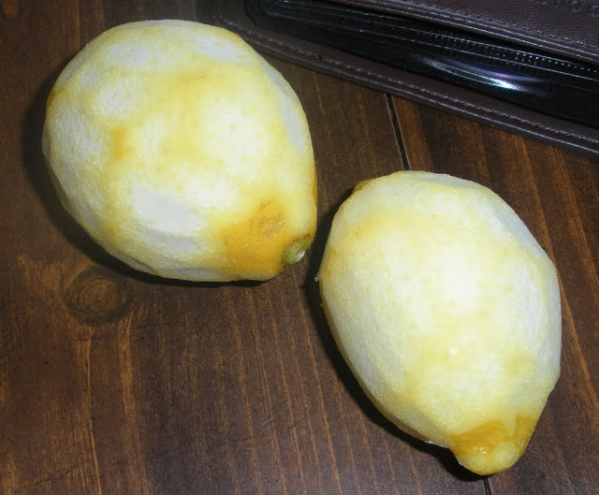
After that take your sugar and lemon peels and muddle them. You want to break up the cells of the peels to release the oils.
After you've worked at that for a spell you should see the oils on the sugar.
This next photo shows the difference. Muddled Lemon peels and sugar on the right and untouched sugar on the left.
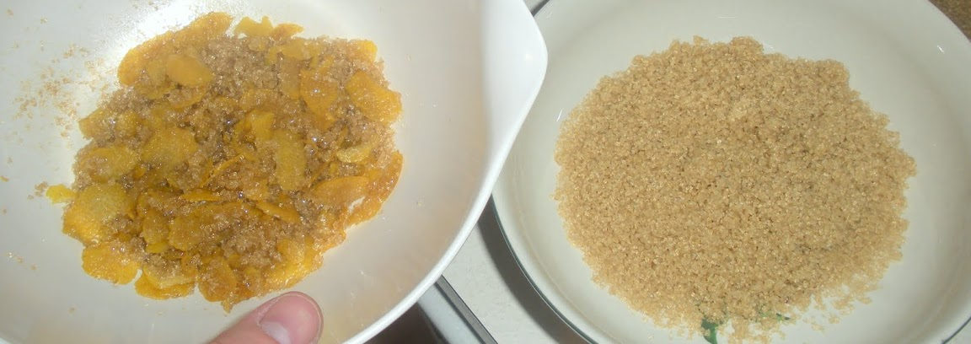
Set this aside in a warm place for about an hour and let the sugar pull more of the oil out.
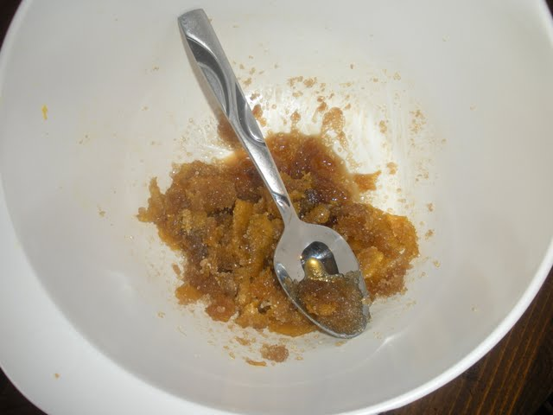
After your "oleo-saccharum" has set for a couple of hours. Take 4oz of lemon juice and mix it in.
Strain out the used peels and set them aside, we have plans for them. Mix the juice and oleo-saccharum well, try and dissolve as much sugar as you can.
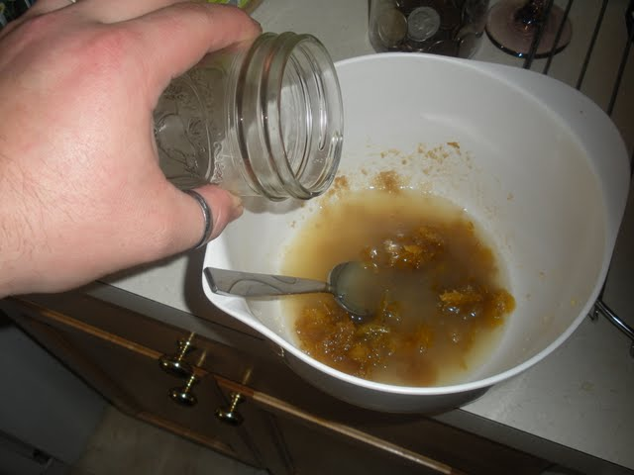
Next heat up 4 oz of water and grab your lemon peels. Mix the 2 and strain out the peels again.
Now combine your Lemon water with your juice/oleo-saccharum and mix well. You should be able to dissolve all the sugar. Taste! Lemons vary so taste and see if you need more sugar. Add too taste, but remember you need that sour. Don't drown it in sugar you'll ruin the punch and make it too sweet.
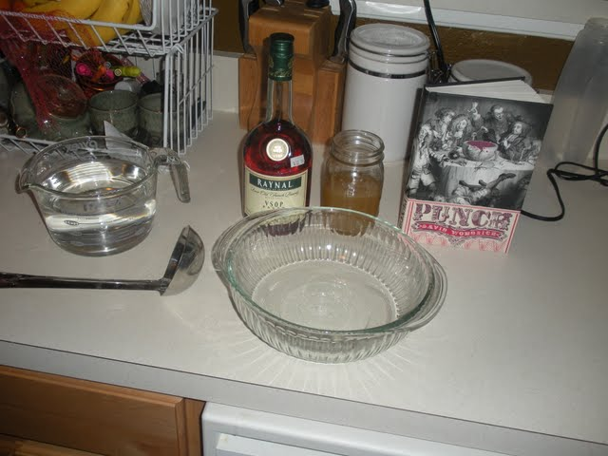
Now measure 16oz of Brandy.
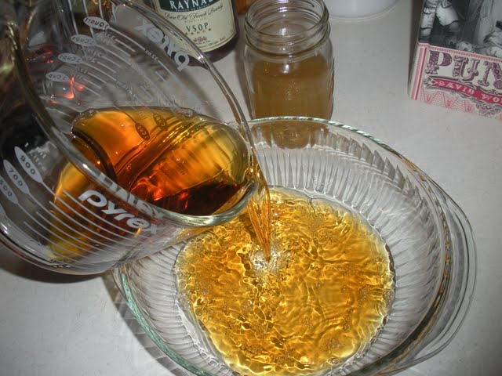
Take a sip to insure it's quality.
Pour in your oleo-saccharum/ lemon juice.
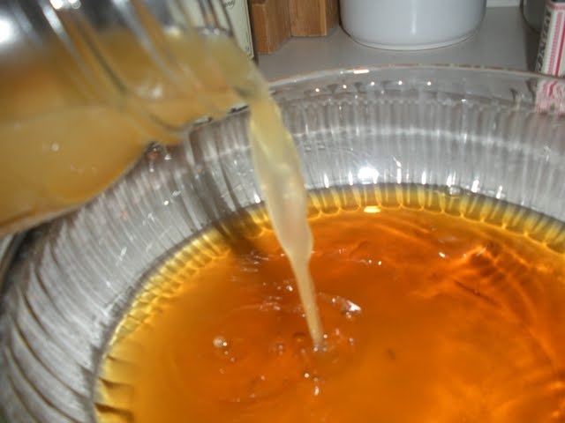
MIX AND ENJOY!!
Edited February 10, 2012 by Jack Roberts

- Quote
- Edit

Jack Roberts
- Dread Pyrate
- Member

- 1,063 posts
- Gender:Male
- Location:Orlando, FL
(IP: 97.103.245.165) · ·
Posted February 1, 2012 · Report post
Conclusion....
I've cut back the water to 24oz instead of 1 quart(32oz) More water made the punch a little insepid.
You may get away with a little more, but start with 24oz and work from there.
Bear in mind punch isn't a cocktail, water is very necessary. It softens the palette and creates a great flavor. Otherwise it would be way too strong and over bearing. Try it, before you add your water give the liquor a taste. I tasted everything throughout the process so I knew what each step does. It helps to understand what an ingredient does in order to adjust things as needed.
I also find that room temp or just slightly colder is best. If you fill a glass with ice and chill the punch down to cocktail temps you lose the nuances of the drink. I like slightly chilled but it's hard to keep it there without dilution.
All in all it's a fantastic drink. Easy going down, when your done your first cup it leaves you wanting more. Absolutely marvelous. I now know why it reigned king for nearly 200 years. So whip up a batch and try it out.
This was a half recipe, should be good for a couple of nights drinking. I've bottled up half of mine for later. Cheers!!

- Quote
- Edit
- Options

Jas. Hook
- Scourge o' the 7 Seas
- Member

- 1,650 posts
- Gender:Male
- Location:Long Island NY
- Interests:Fishing & Piracy
(IP: 198.8.4.10) · ·
Posted February 2, 2012 · Report post
On 2/1/2012 at 10:50 PM, Jack Roberts said:
Ok so here I'm going to show how I'm making a simple Brandy Punch.
Fairly common for our time period in England. It's called Major Bird's Brandy Punch Ingredients for are:
MIX AND ENJOY!!
JR -
Thanks for the recipe. I wonder if I can substitute Splenda for the sugar?
The Quality Assurance Test photo in the middle is priceless.
Jas. Hook

- Quote
- Edit
- Options

Mission
- Goat Specialist
- Admin

- 5,083 posts
- Gender:Male
- Location:Monroe, MI
- Interests:Scholarly piracy, designing and creating haunted house rooms and props, movies, abstract thinking, abstruse thinking, obstructive thinking, ideating, random thinking, movies, cartoons, movies, movies scores, cycling, world peace and small furry dogs, movies, writing, drawing, personal skills training, gremlins and, of course, lest I forget, movies.
(IP: 75.128.82.198) · ·
Posted February 2, 2012 · Report post
If I had my DVD with me, I'd screen capture Sheldon photographing his scrambled eggs and post it here. Alas.
"Okay, I'll let you get back to fixing your eggs."
"I’m not just fixing my eggs, I’m fixing everyone’s eggs."
"And we all thank you."

- Quote
- Edit
- Options

landlubbersanonymous
- Plunderer
- Member

- 354 posts
- Gender:Not Telling
- Location:California, USA
- Interests:History, arts, collecting, reenacting
(IP: 72.67.12.99) · ·
Posted February 2, 2012 · Report post
On 2/1/2012 at 10:50 PM, Jack Roberts said:
The receipe is from "Punch" by David Wondrich and is our kind of writer. He's pulled from as many period resources as possible....
Thank ye Mister Roberts! We'll investigate same.
Reference ISBN-13 9780399536168

- Quote
- Edit
- Options

Capt. Sterling
- Sticky Fingers Sterling Needs a New Hat
- Member

- 10,302 posts
- Gender:Pyrate Hunter
- Location:here
- Interests:Killing pirates, haven't met one yet worth keeping alive....
(IP: 71.51.27.237) · ·
Posted February 2, 2012 · Report post
Careful, putting L'il Snot to work on alcoholic beverages could constitute some sort of contributing to the delinquinsey of a minor....oh wait, she's a reenactor...never mind...

- Quote
- Edit
- Options

Jack Roberts
- Dread Pyrate
- Member

- 1,063 posts
- Gender:Male
- Location:Orlando, FL
(IP: 97.103.245.165) · ·
Posted February 2, 2012 · Report post
LOL! Sterling
Jas, try Splenda in the Raw, not sure if it contains the molasses flavor but it might. This reciepe makes about 6.5 cups. Many servings for sure. Try and scale it down to see if the splenda works.

- Quote
- Edit
- Options

Jas. Hook
- Scourge o' the 7 Seas
- Member

- 1,650 posts
- Gender:Male
- Location:Long Island NY
- Interests:Fishing & Piracy
(IP: 71.125.231.103) · ·
Posted February 4, 2012 · Report post
Thankee JR.
I'll seek out the Splenda Raw tomorrow and mix up a wee batch. Just be hope'n me Endocrinolo-lass don't be flippn' her wig.
Jas. Hook

- Quote
- Edit
- Options

James Smythe
- Ship's Master
- Member

- 175 posts
- Gender:Male
- Location:Where the winds may take me.
- Interests:Pyrates, ukulele, beaches, bowling, reading, video games
(IP: 76.2.188.195) · ·
Posted February 5, 2012 · Report post
On 2/1/2012 at 10:54 PM, Jack Roberts said:
I also find that room temp or just slightly colder is best. If you fill a glass with ice and chill the punch down to cocktail temps you lose the nuances of the drink. I like slightly chilled but it's hard to keep it there without dilution.
Funny thing... I am reading If a Pirate I Must Be by Richard Sanders and just came across rum punch. It made note of serving hot punch in the mornings. Maybe this drink is a warm drink?

- Quote
- Edit
- Options

jendobyns
- Pyrate Captain
- Member

- 562 posts
- Gender:Female
- Location:Baltimore
- Interests:too numerous to mention, really. Period foodways, baroque dance, material culture, etc., etc.
(IP: 72.81.182.183) · ·
Posted February 5, 2012 · Report post
Ah, it must be punch season My husband and I are bottling up the batch of Fish House Punch we made for this year's events. Last year's batch took about 3 months to properly mellow so we played with it a bit this time. I'll have to try the Brandy punch, too.
Is there a recipe for Arrack Punch in this book? I'm on the lookout for a good one to experiment with to add to the collection.

- Quote
- Edit
- Options

Jas. Hook
- Scourge o' the 7 Seas
- Member

- 1,650 posts
- Gender:Male
- Location:Long Island NY
- Interests:Fishing & Piracy
(IP: 71.125.231.103) · ·
Posted February 5, 2012 · Report post
JR -
Tried 1 lemon, 1 tbsp of baking Splenda (couldn't find raw), 1 cup of water and a 50 ml mini bottle of VSOP. It sorta' turned out a short tumbler sized personal size drink. Turned out OK, a bit odd using the Splenda but still palatable. I got a little worried when mixing the Splenda and the lemon zest, it was becoming a bit pastey but thinned out OK. Next time I'll try a drop or two of molasses for aging.
Not bad for a first try.
Jas. Hook

- Quote
- Edit
- Options

Jack Roberts
- Dread Pyrate
- Member

- 1,063 posts
- Gender:Male
- Location:Orlando, FL
(IP: 173.245.64.101) · ·
Posted February 6, 2012 · Report post
Yes and yes!
Punch can be served hot.
Punch can be served with Arrack, and there are several recipes of Arrack punch. So much so, personally being on the PC side of things, it seems really popular for the period. One must must really purchase the book. Highly recommended for the recipes and research.

- Quote
- Edit
- Options

jendobyns
- Pyrate Captain
- Member

- 562 posts
- Gender:Female
- Location:Baltimore
- Interests:too numerous to mention, really. Period foodways, baroque dance, material culture, etc., etc.
(IP: 72.81.182.183) · ·
Posted February 7, 2012 · Report post
Thanks. The "look inside" bit from Amazon was interesting, but not quite helpful enough. He seems to have a very different method than the period receipts I have seen so far. Interesting. I'll be getting the book. *G*
And I can totally understand why Arrack punch would be popular, having tried it myself. Very nice indeed!
Oh, and Fish House Punch is supposed to be older than the references mentioned. I'll have to check with my source to see how early his are. But as he's an academic, and quite PC, I trust his judgement.

- Quote
- Edit
- Options

James Smythe
- Ship's Master
- Member

- 175 posts
- Gender:Male
- Location:Where the winds may take me.
- Interests:Pyrates, ukulele, beaches, bowling, reading, video games
(IP: 131.151.86.127) · ·
Posted February 9, 2012 · Report post
On 2/2/2012 at 8:29 PM, landlubbersanonymous said:
On 2/1/2012 at 10:50 PM, Jack Roberts said:
The receipe is from "Punch" by David Wondrich and is our kind of writer. He's pulled from as many period resources as possible....
Thank ye Mister Roberts! We'll investigate same.
Reference ISBN-13 9780399536168
Looking into this book.

- Quote
- Edit
- Options

Jack Roberts
- Dread Pyrate
- Member

- 1,063 posts
- Gender:Male
- Location:Orlando, FL
(IP: 97.103.245.165) · ·
Posted February 12, 2012 · Report post
Trying a rhum punch today! I'm doing more of the simple recipes first then I'll graduate to the more complicated milk and royal punches later.

