Quartermaster James
- LUNATIC
- Member

- 1,662 posts
- Gender:Male
- Location:Sailing the Islets of Langerhans
- Interests:Interests cannot be left blank, so the machine says.
(IP: 8.7.69.37) ·
Posted February 14, 2009 (edited) · Report post
Does anybody have any information, advice, experience, or plans they care to share for building stocks?
You can imagine what results a web search gives! Have to refine my search terms!
Edited February 14, 2009 by Quartermaster James

- Quote
- Edit

Graydog
- Notorious Pyrate
- Member

- 796 posts
- Gender:Polly Wanna Cracker
- Location:The Sea
- Interests:My interest is becoming a one percenter so I can laugh at the 99 percenters. HAHAHAHAHAHA, Wow, guess I made it. Yo Ho.
(IP: 71.95.51.46) · ·
Posted February 16, 2009 · Report post
Here ya go:
Pillory Plans

- Quote
- Edit
- Options

Quartermaster James
- LUNATIC
- Member

- 1,662 posts
- Gender:Male
- Location:Sailing the Islets of Langerhans
- Interests:Interests cannot be left blank, so the machine says.
(IP: 8.7.69.38) · ·
Posted February 17, 2009 · Report post
Graydog said:
Here ya go:
Pillory Plans
Thanks mate!

- Quote
- Edit
- Options

MadL
- Dread Pyrate
- Member

- 1,283 posts
- Gender:Male
- Location:Where ever I need ta be
- Interests:I like pirates, ye got a problem with that?
Blame me mu'm, she the one who decked me room out like a captain's cabin an' that be what I grew'd up in. Also me pa fer he built boats when I was but a wee lad. Later they ran off an' joined the carnivals, so I learn ta be a scalawag from the best.
I like weapons, some that go BOOM, and always sharp shiny ones.
I work with computers, currently contracted to hire by Xerox, their engineers [I]Need[/I] all the help they can get, this is fer sure! But I also have taught the Microsoft Certification course for a private contact school, an' spent 4 years working third level support at Earthlink before that scalawag Sky jumped ship an' let it go down.
They call me Mad L cuz, well, cuz many think I be mad, mad as a hatter they say but that only because they never jumped from a perfectly good airplane....over a thousand times. They also call me Mad L cuz I don't much like dogs n' cats, but I like things with scales and teeth, even the venomous ones for they be quit tasty when roasted over an open flame....even bet'r wit rum! They also call me Mad L, well, cuz very few know how to say me sir name properly, so in the military they give up and just call me "Mad L"
Oh, an' I dabble in the arts, computer 3D arts that be. Thar they all think I be mad, I do me best to make sure they all know I be mad. I have fun run'n amok as a pirate monkey character and makin' the moderators thar go bald. Several times the moderators try ta toss me o'r board, but the crew say will have none o' that now ;\
So, I like pirates, ye got a problem with that?
(IP: 4.131.157.43) · ·
Posted February 17, 2009 · Report post
Quartermaster James said:
Does anybody have any information, advice, experience, or plans they care to share for building stocks?
Well, I be no broker...but ye may want ' avoid Exxon

- Quote
- Edit
- Options

michaelsbagley
- Smells Like Wet Sheep
- 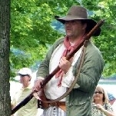
- Moderator

- 2,548 posts
- Gender:Male
- Location:Columbus, Ohio
- Interests:Mostly into GAoP, but starting to develop more Buccaneer era stuff for re-enacting as well. Generally I do re-enact both piratical/nautical and other impressions from the period. I am focusing on more "common" impressions from the period (i.e. average sailor/pirate, rank and file Red Coat, early Colonial huntsman, etc.)
(IP: 199.230.203.254) · ·
Posted February 17, 2009 · Report post
I'm glad GrayDog answered this, as I was about to send a bunch of links to late 18th century neck adornments...

- Quote
- Edit
- Options

Capt. Sterling
- Sticky Fingers Sterling Needs a New Hat
- Member

- 10,302 posts
- Gender:Pyrate Hunter
- Location:here
- Interests:Killing pirates, haven't met one yet worth keeping alive....
(IP: 71.53.214.64) · ·
Posted February 17, 2009 · Report post
Our crewe travels with a leg pillory... the head pillory is in the works...
but these might help... hardest thing is getting pc hardware... you need to find a blacksmith
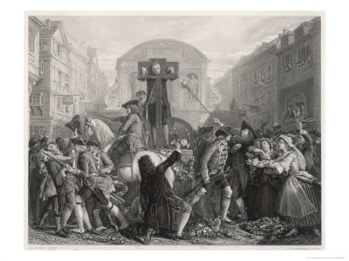Defoe in the pillory
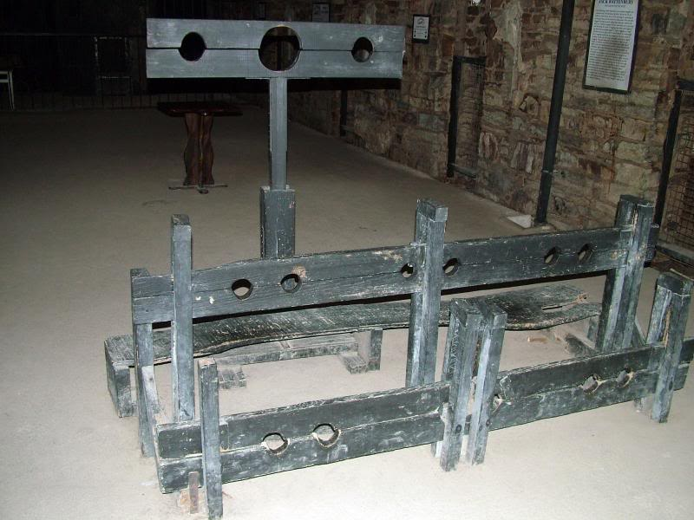
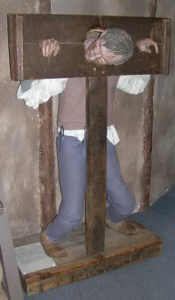
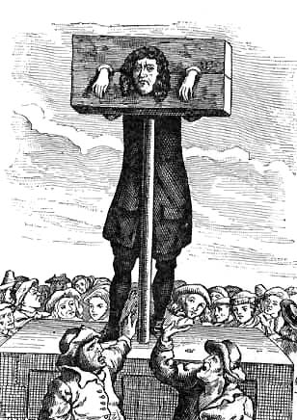
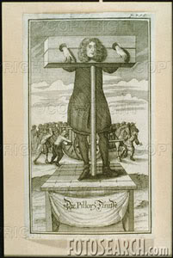

- Quote
- Edit
- Options

Capt. Sterling
- Sticky Fingers Sterling Needs a New Hat
- Member

- 10,302 posts
- Gender:Pyrate Hunter
- Location:here
- Interests:Killing pirates, haven't met one yet worth keeping alive....
(IP: 71.53.214.64) · ·
Posted February 17, 2009 · Report post
Remember when using the head pillory, your victim's ear should be nailed to the wood...

- Quote
- Edit
- Options

Animal
- Buccaneer
- Member

- 903 posts
- Gender:Male
- Location:Treasure Coast, FL
(IP: 68.202.15.30) · ·
Posted February 17, 2009 · Report post
Stirling, my good friend!!! I was wondering if you could post a short list of the errors one might commit to be encased in your pillor? Just for information of course, God knows I would never commit such acts.
Animal

